HU Extension **Assignment 07** E-63 Big Data Analytics

**Problem1**

**Find piggybank.jar file location**

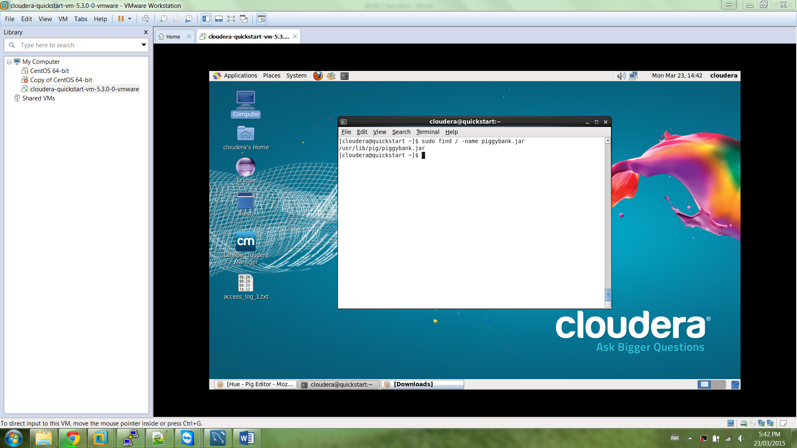

**Sign in to Hue using cloudera username**

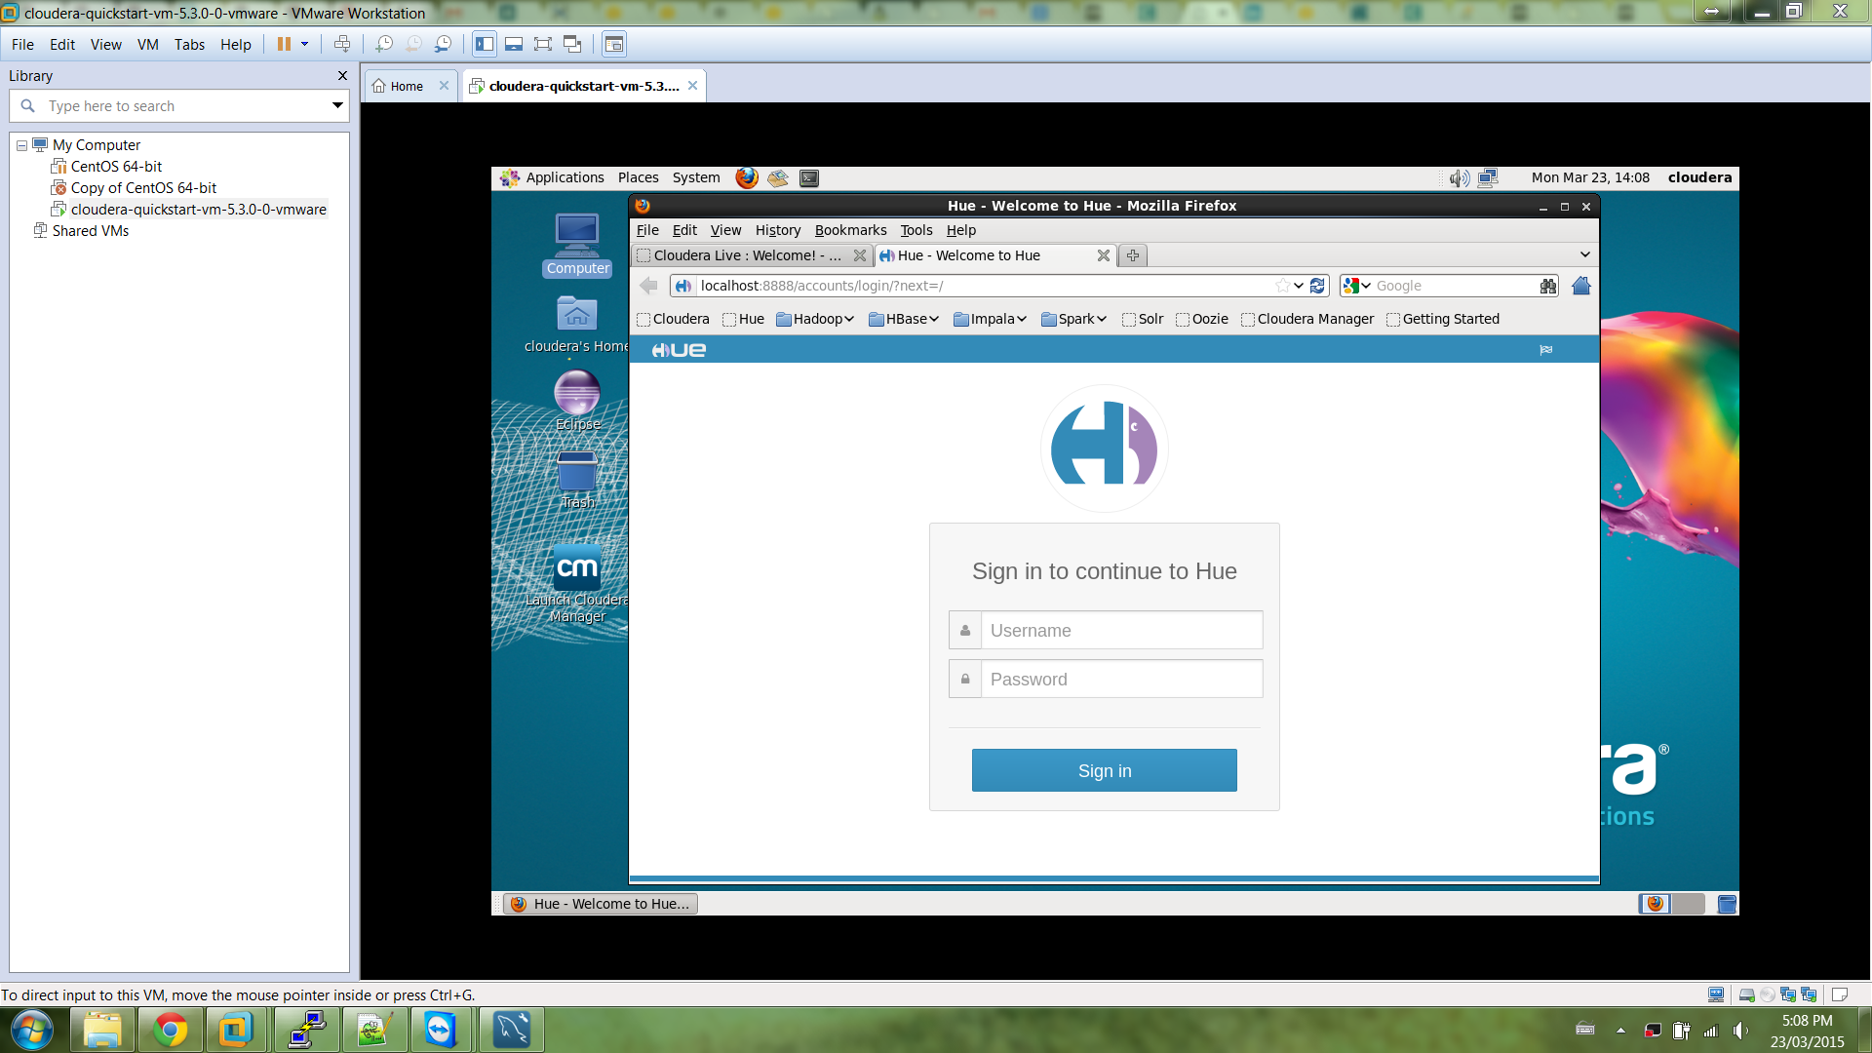

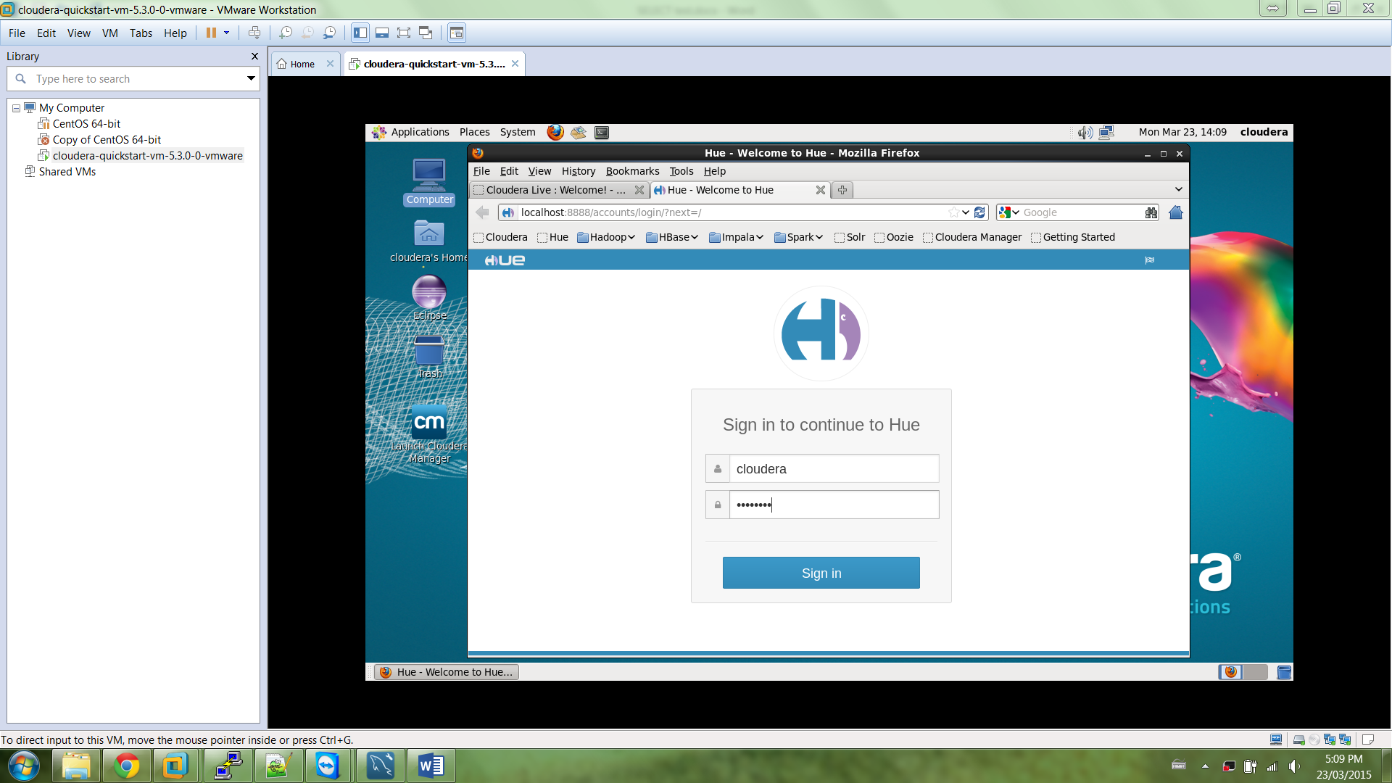

**Go to Pig Editor**

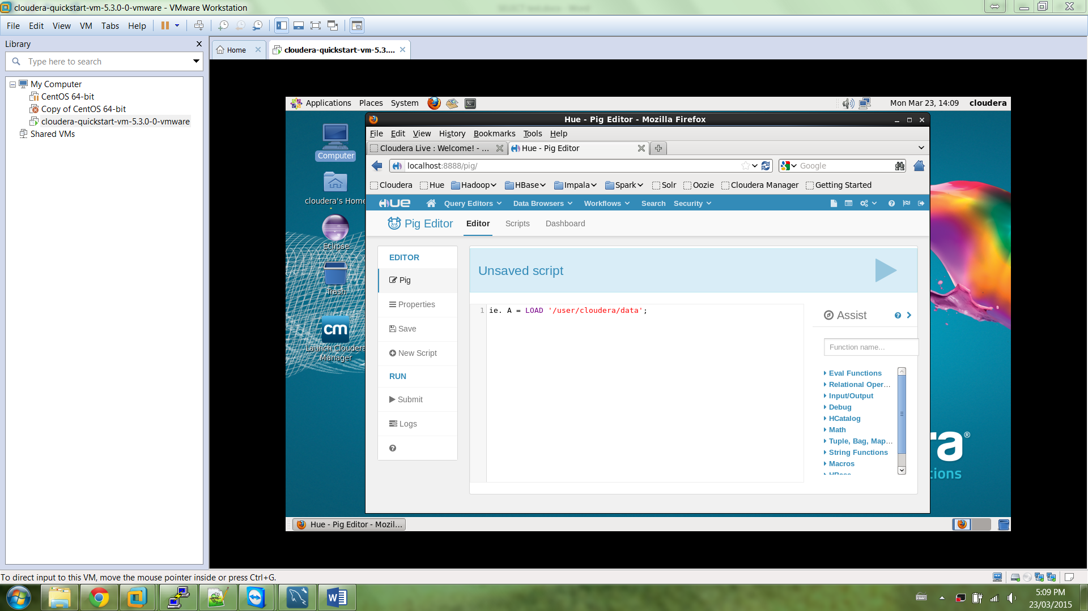

**Put input file access_log_1.txt into Hadoop input folder**

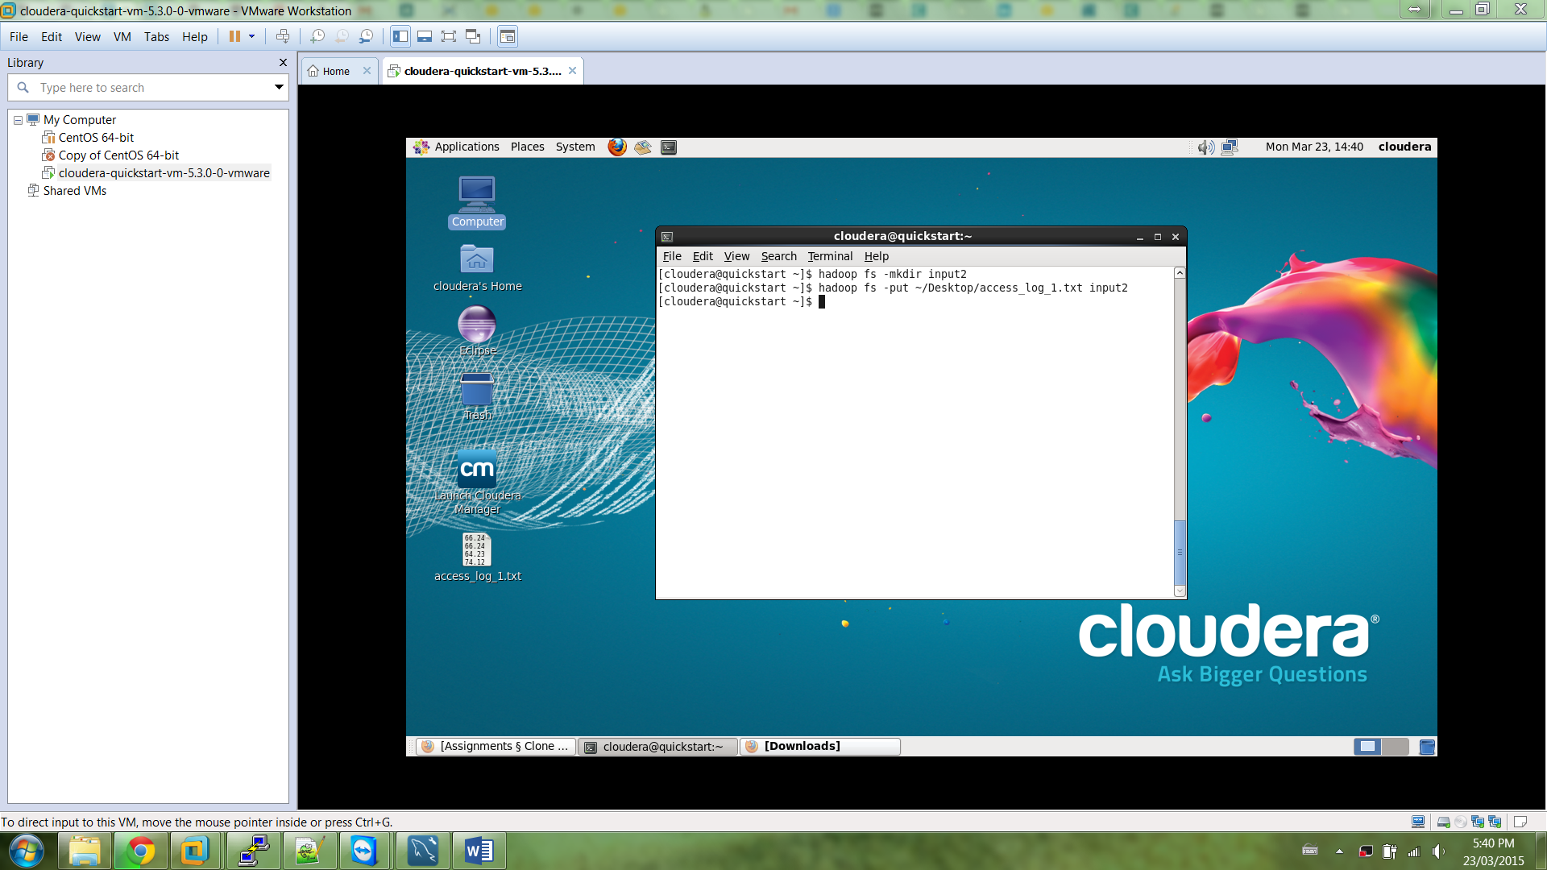

**Copy script.pig into Pig Editor**

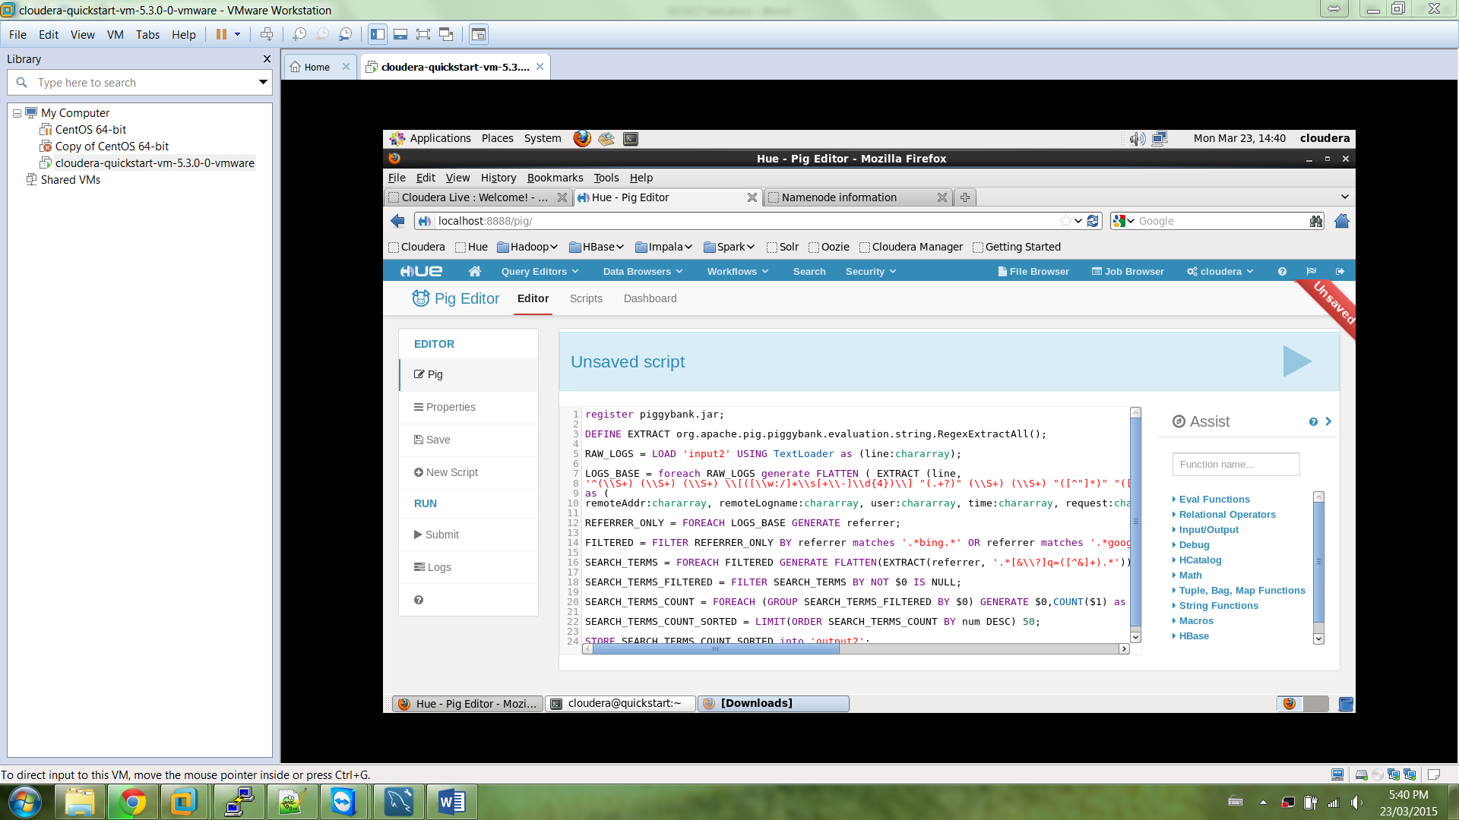

**Edit location of piggyback.jar file in script**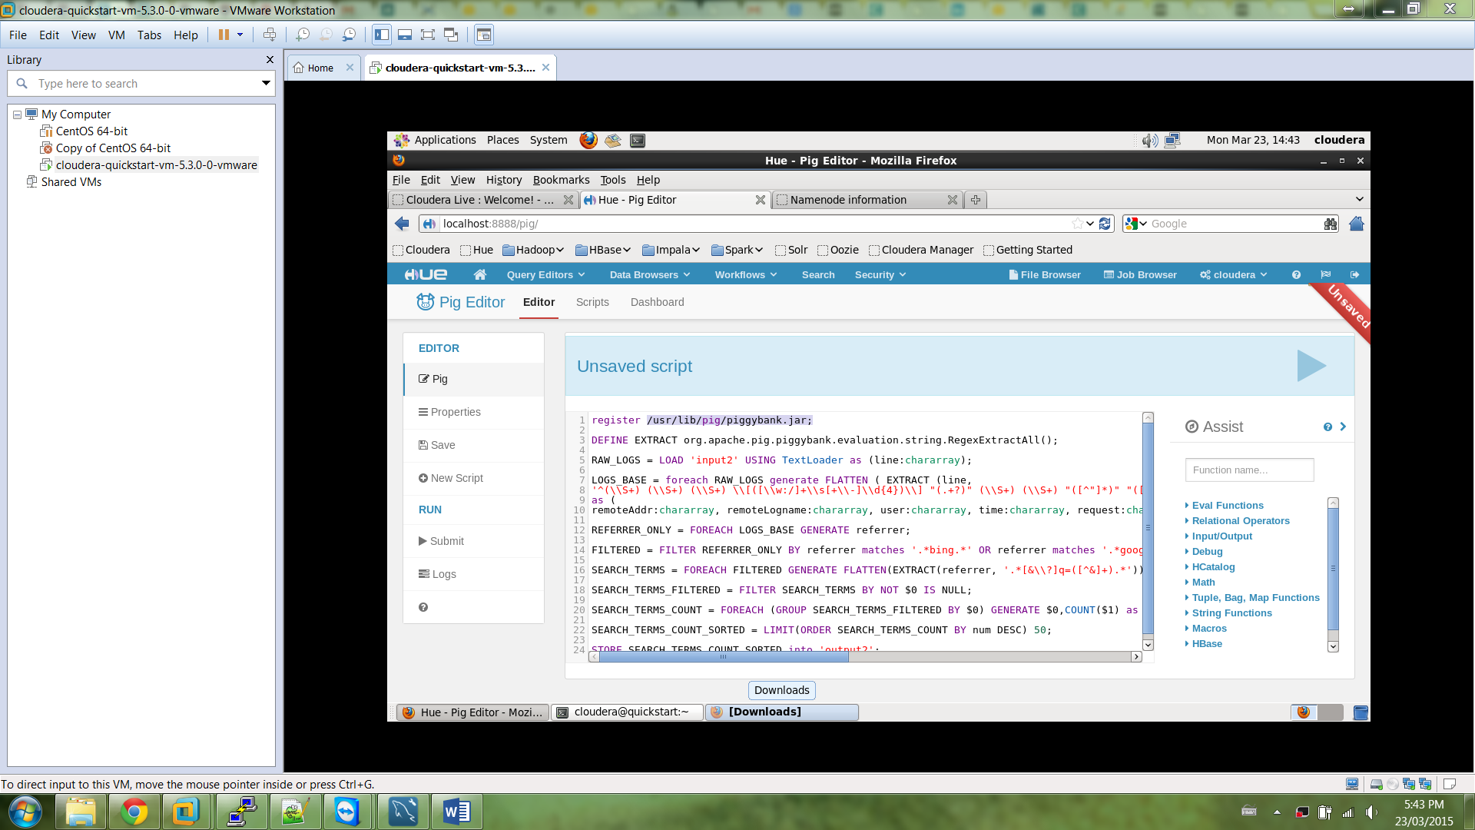

**Insert correct output folder**

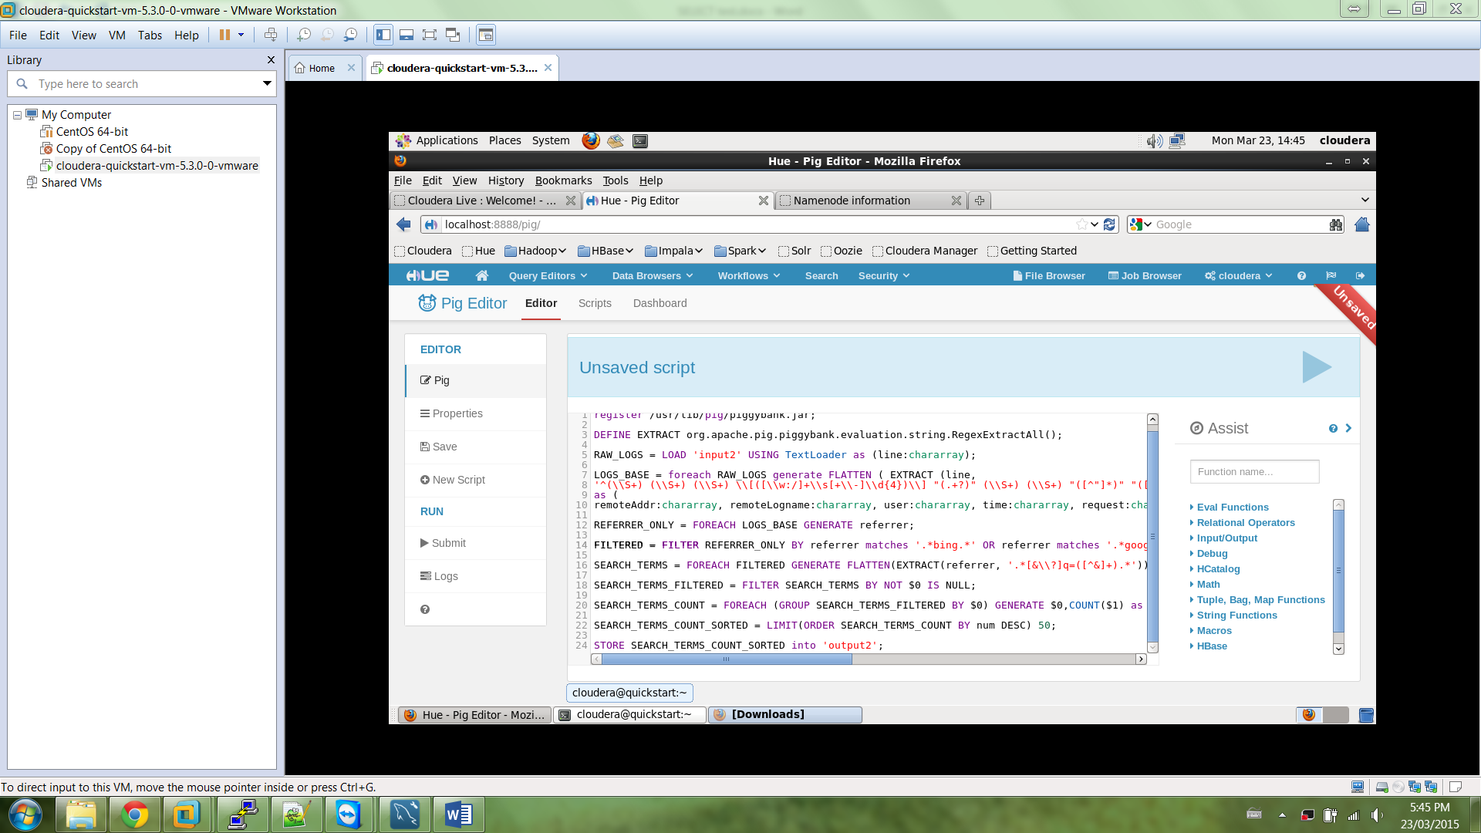

**Run the script.pig**

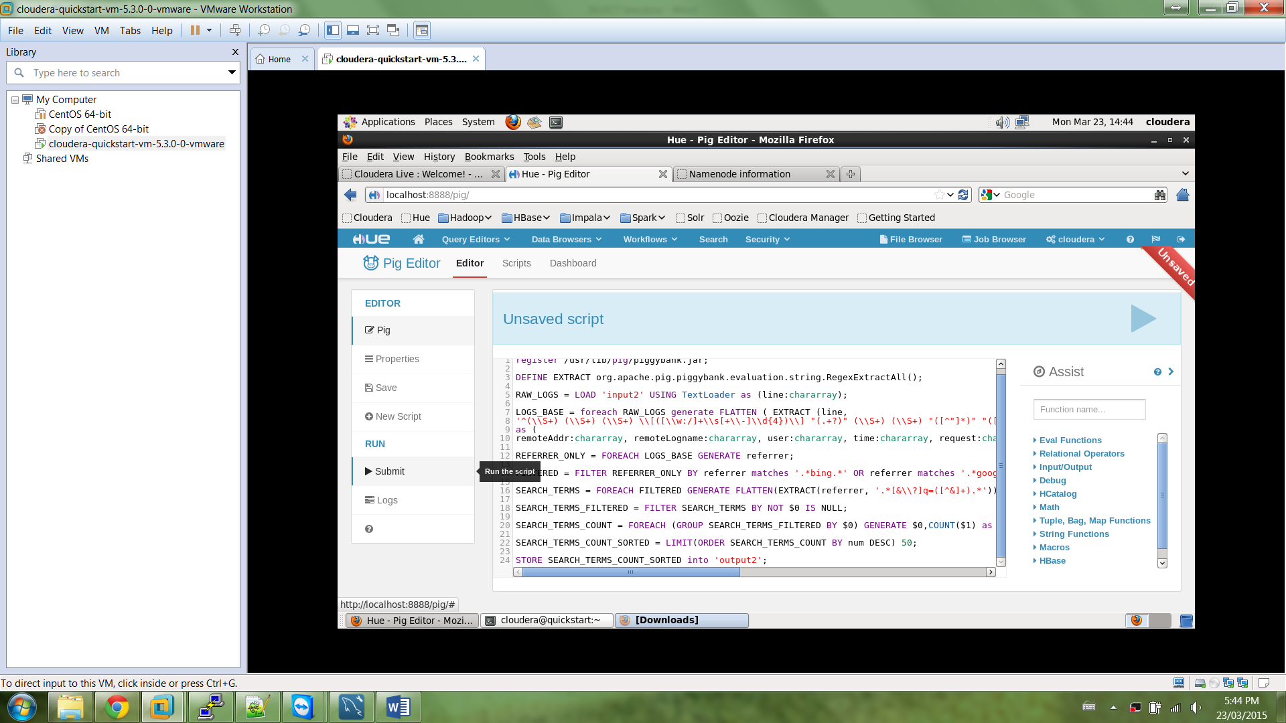

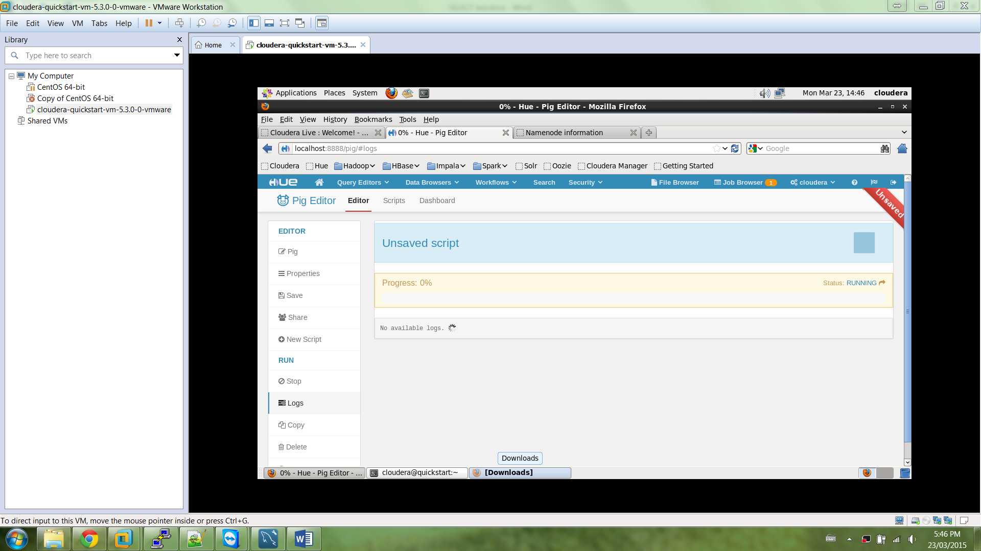

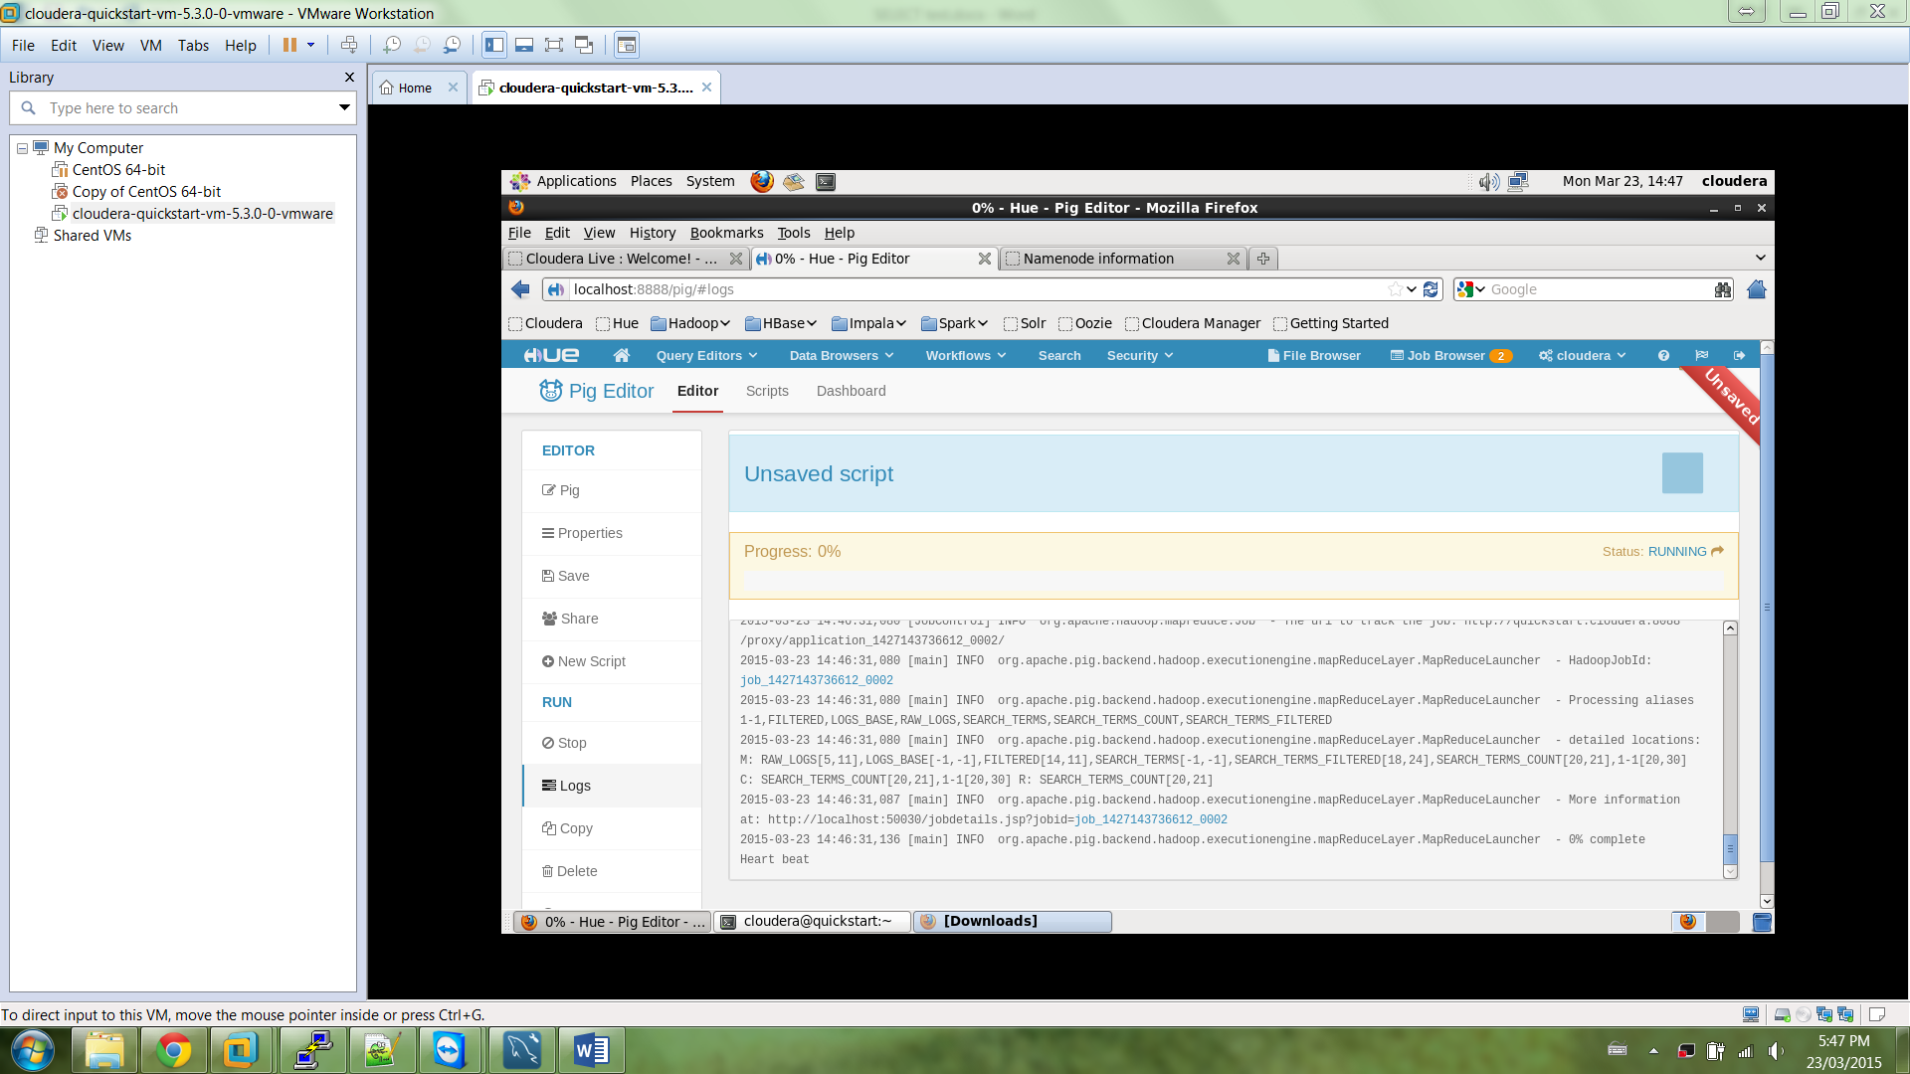

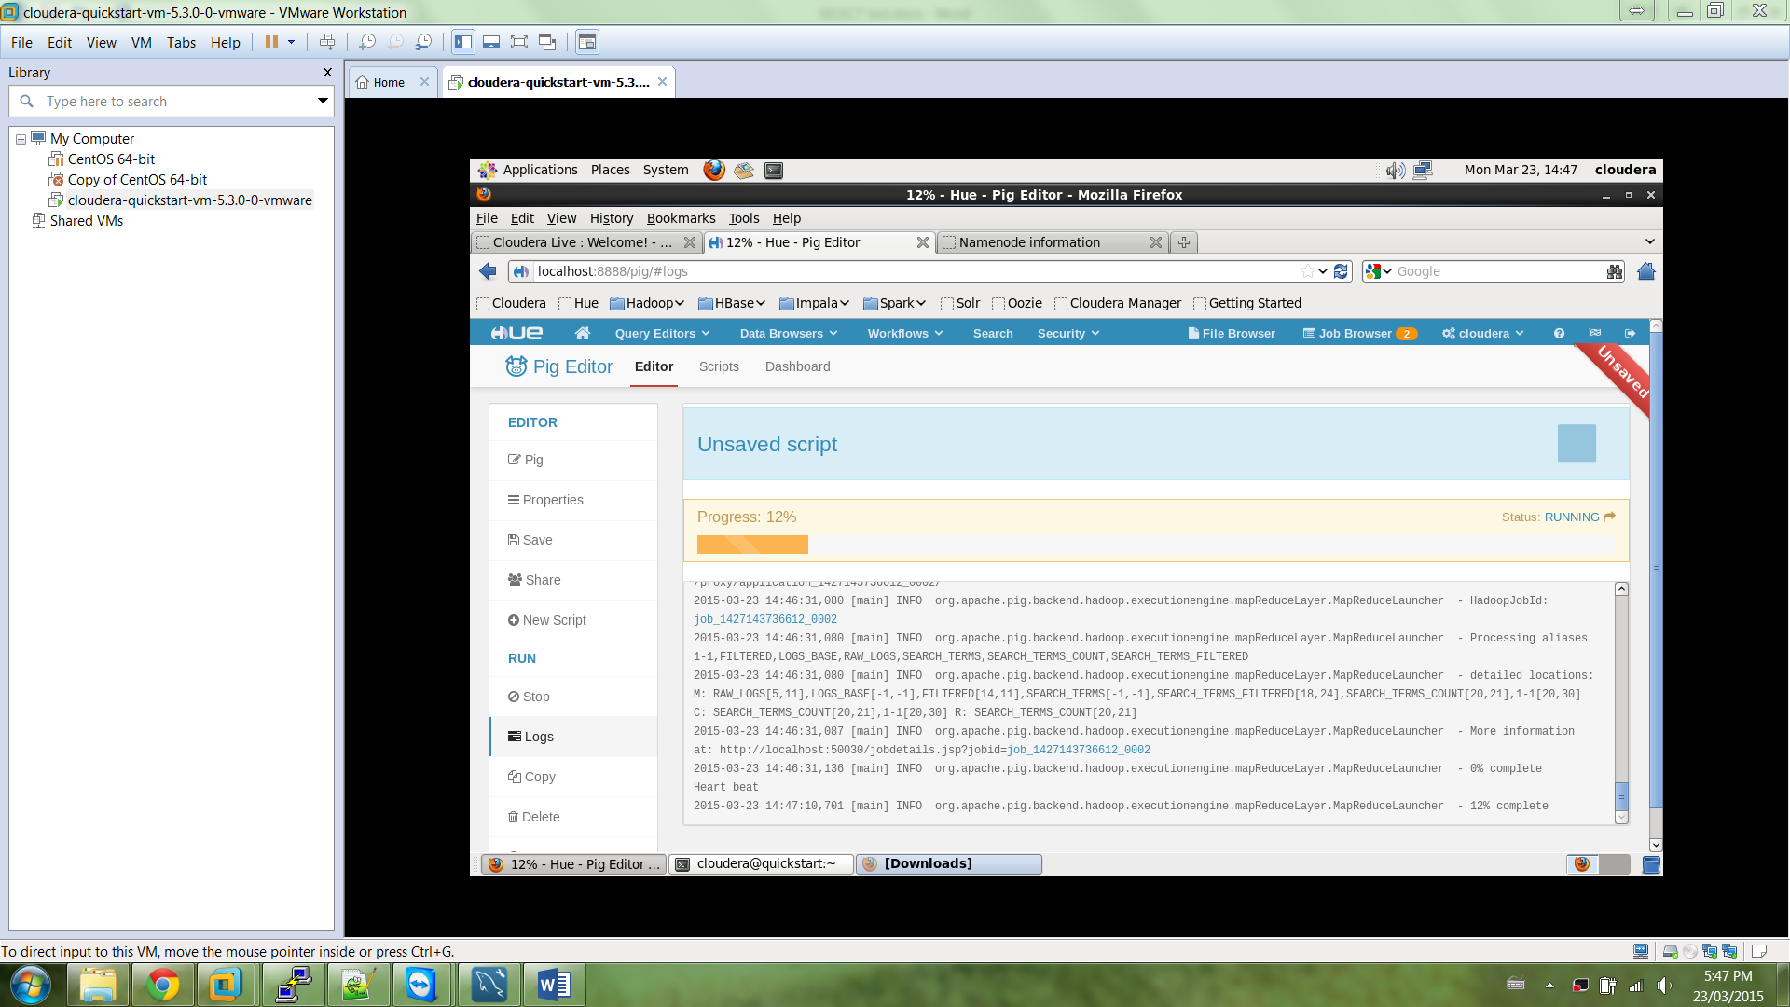

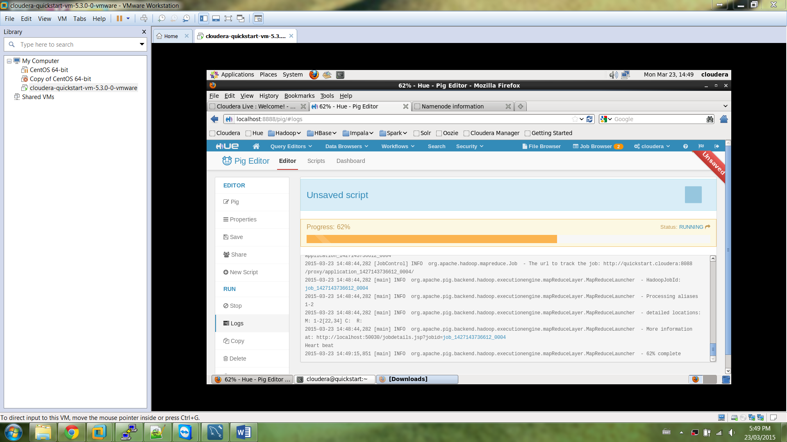

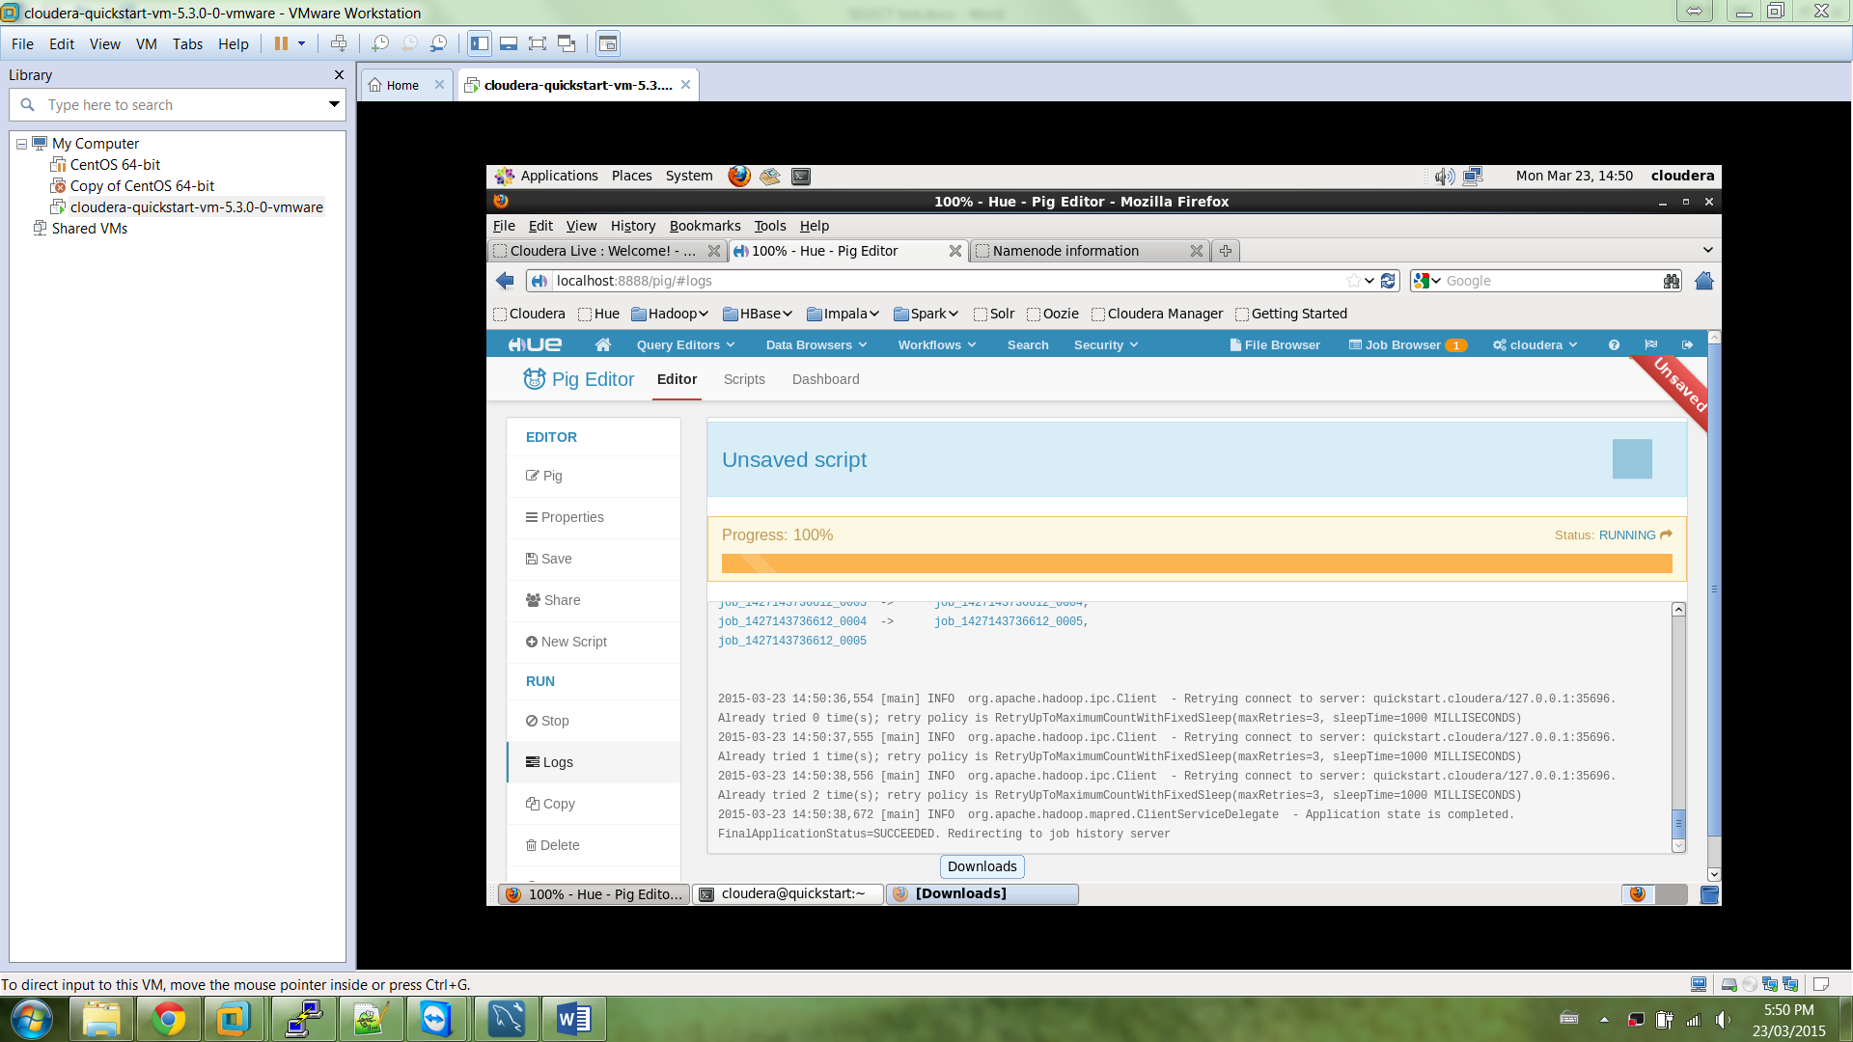

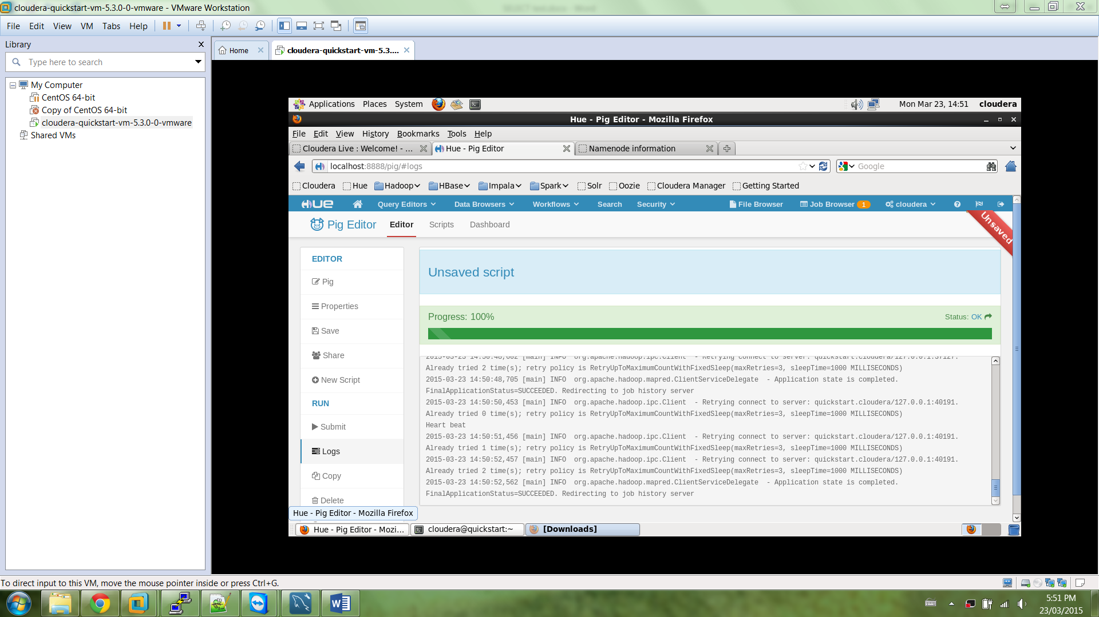

**Check output in “output2” folder**

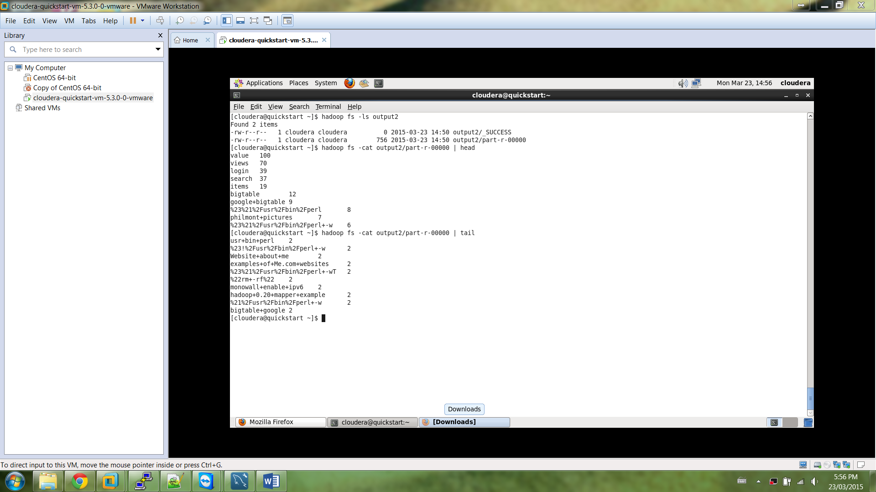

**Problem 2**

Part 1 - Testing on first 10000 lines of input file (input folder “input_problem2”)

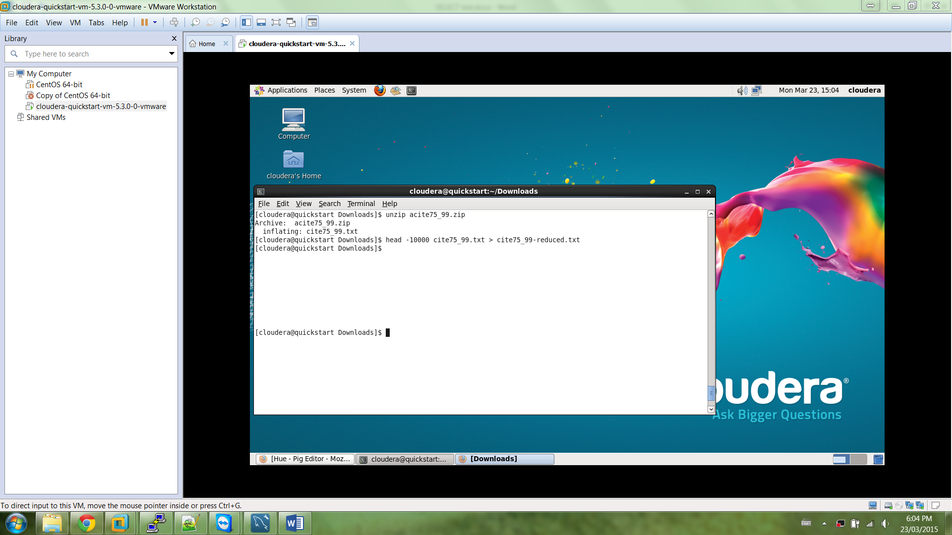

register /usr/lib/pig/piggybank.jar;

DEFINE EXTRACT org.apache.pig.piggybank.evaluation.string.RegexExtractAll();

A = LOAD 'input_problem2' USING PigStorage(',') as (

citing:int, cited:int);

B = GROUP A BY cited;

C = FOREACH B GENERATE $0, $1.citing;

STORE C into 'output_problem2.1';

**Insert above code into Pig Editor**

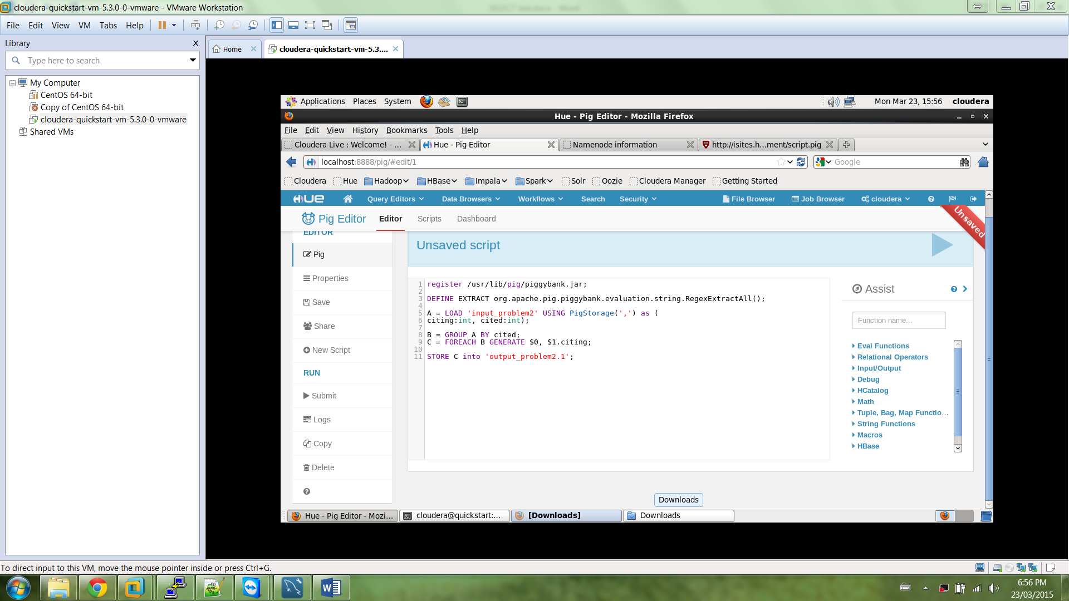

**Run Script**

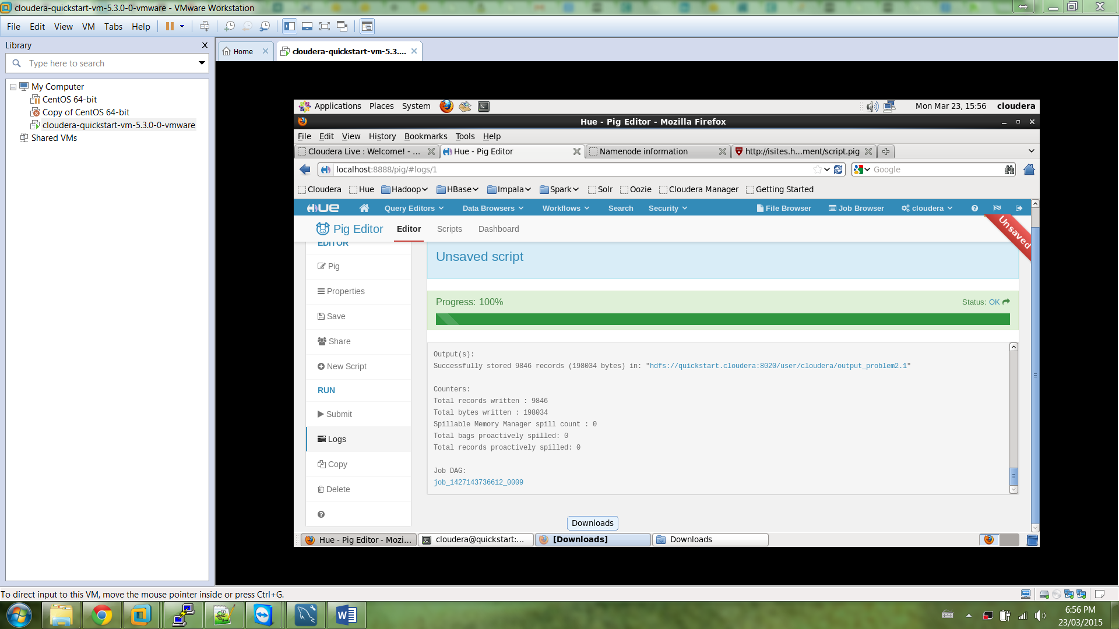

**Check output folder**

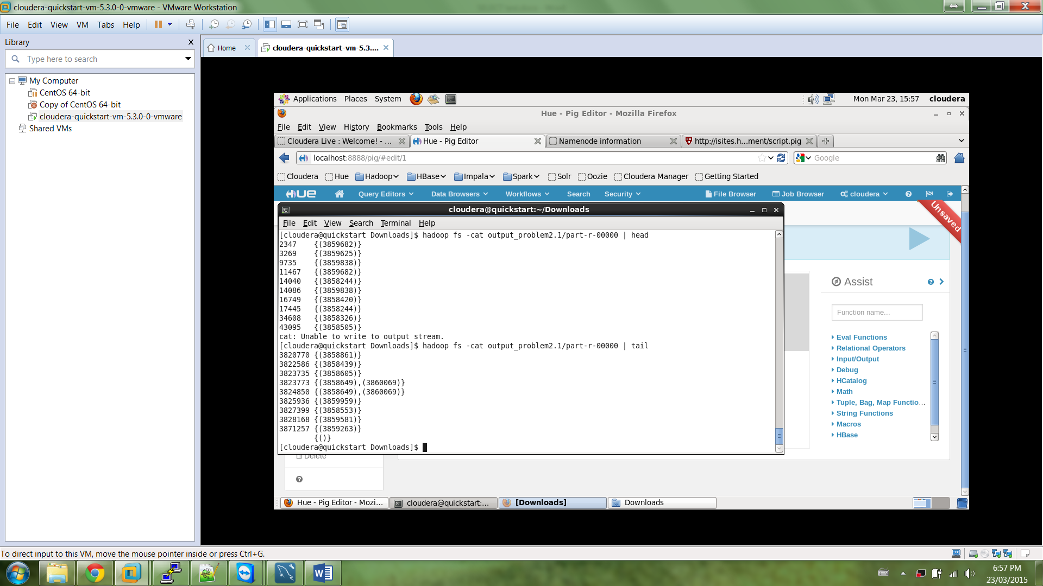

**Part 2 - Using the complete input file (****input folder “input_problem2.1”)**

**Insert file in input folder “input_problem2.1”**

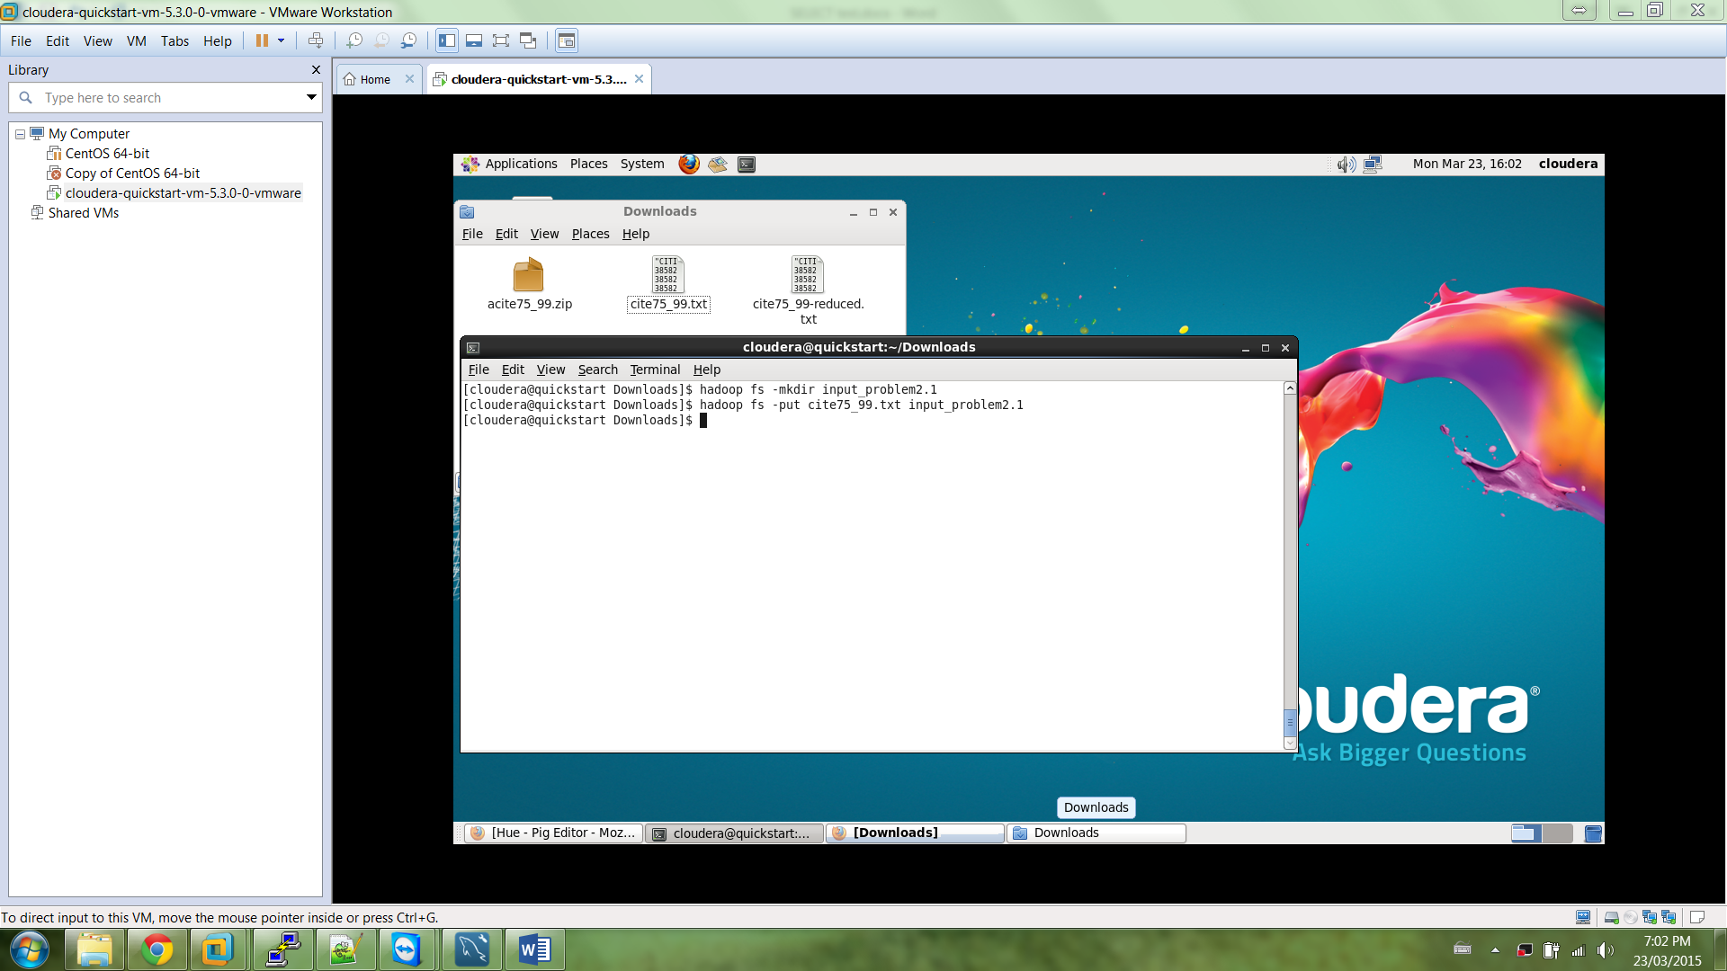

**Modify code to take input from new folder**

register /usr/lib/pig/piggybank.jar;

DEFINE EXTRACT org.apache.pig.piggybank.evaluation.string.RegexExtractAll();

A = LOAD 'input_problem2.1' USING PigStorage(',') as (

citing:int, cited:int);

B = GROUP A BY cited;

C = FOREACH B GENERATE $0, $1.citing;

STORE C into 'output_problem2.2';

**Insert code into Pig Editor**

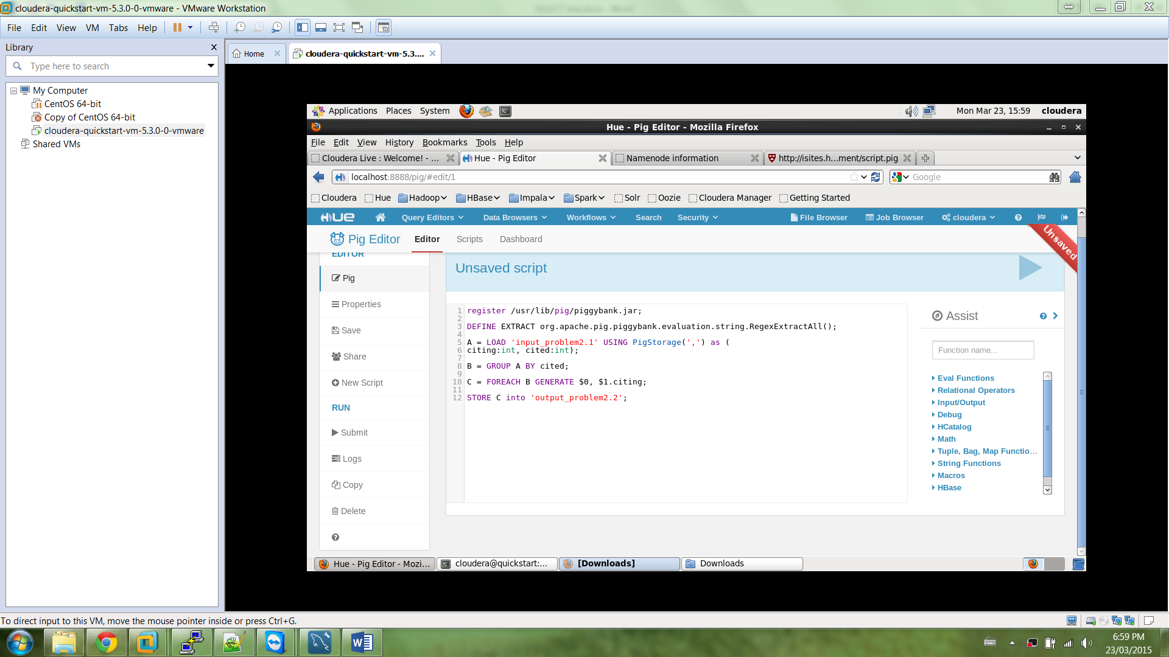

**Save Script**

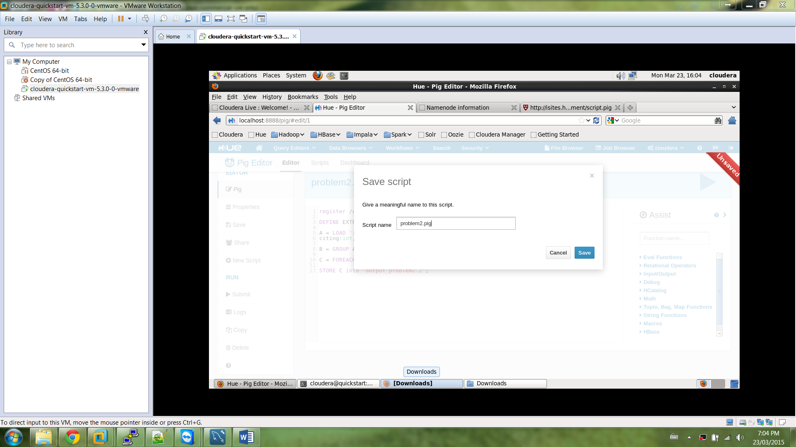

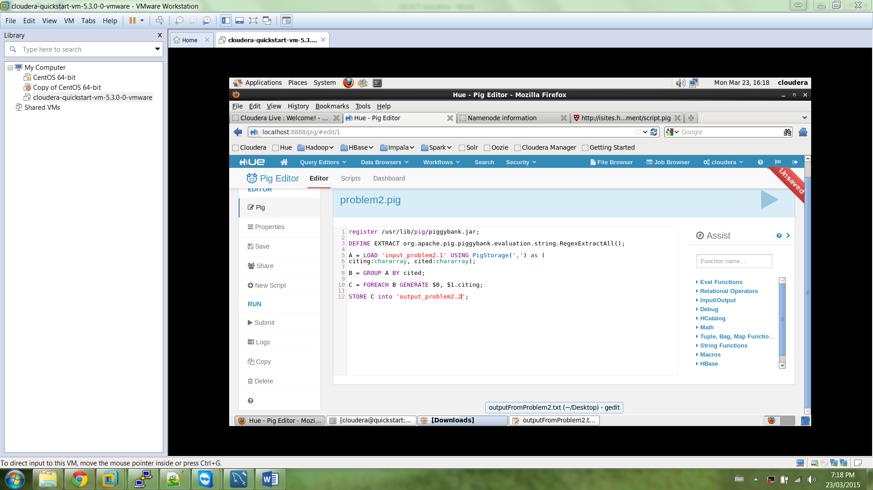

**Run script**

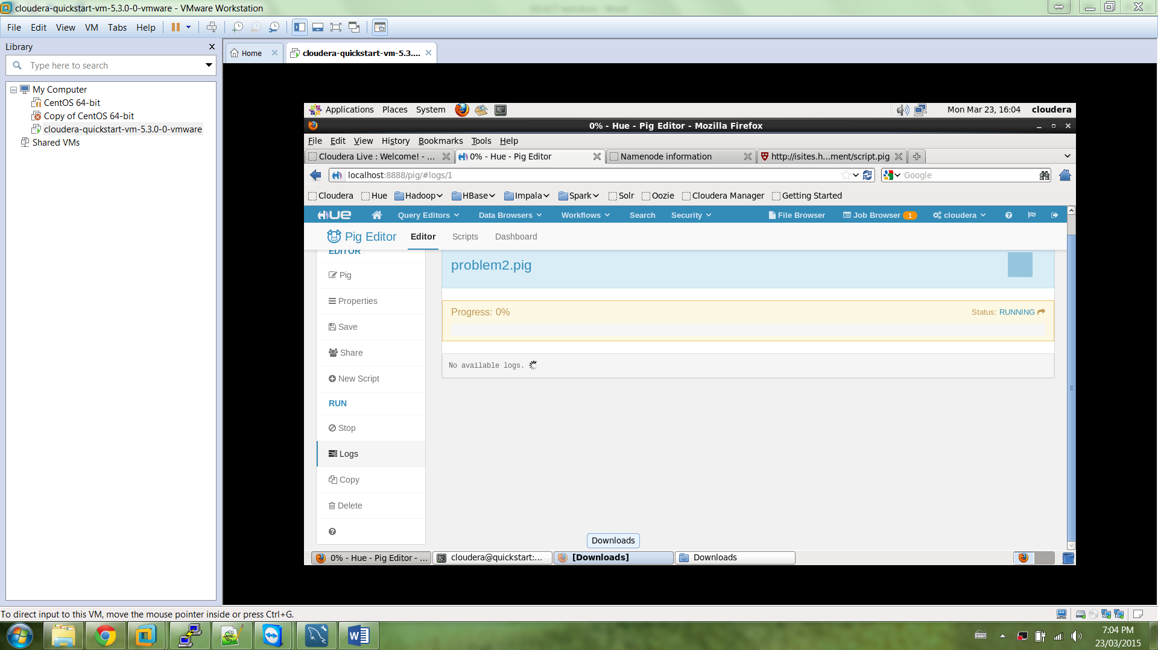

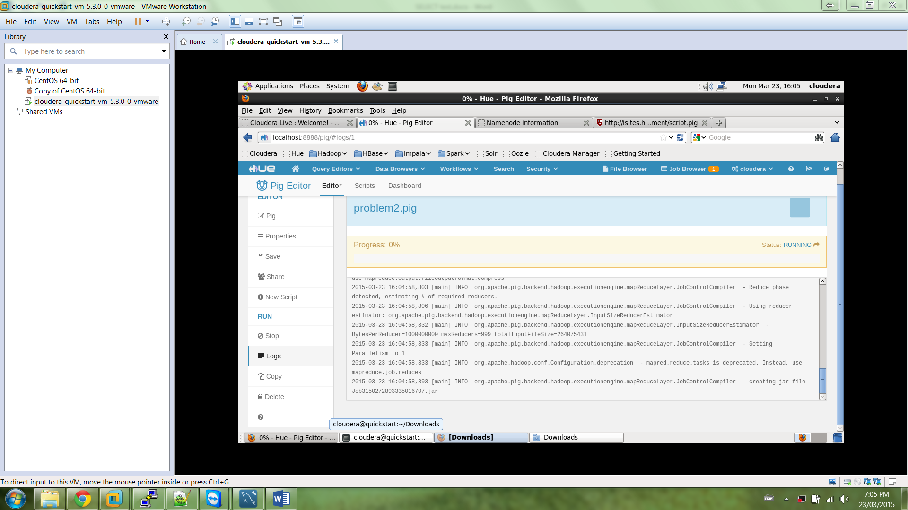

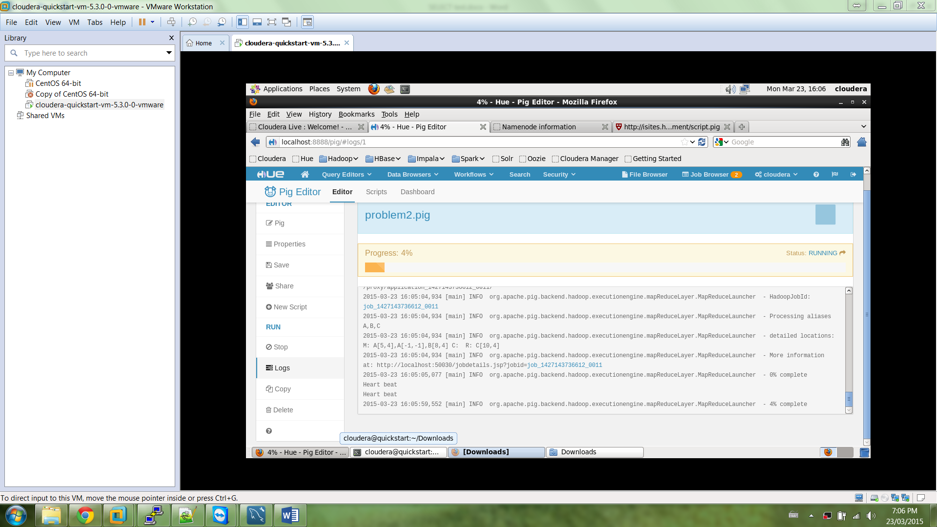

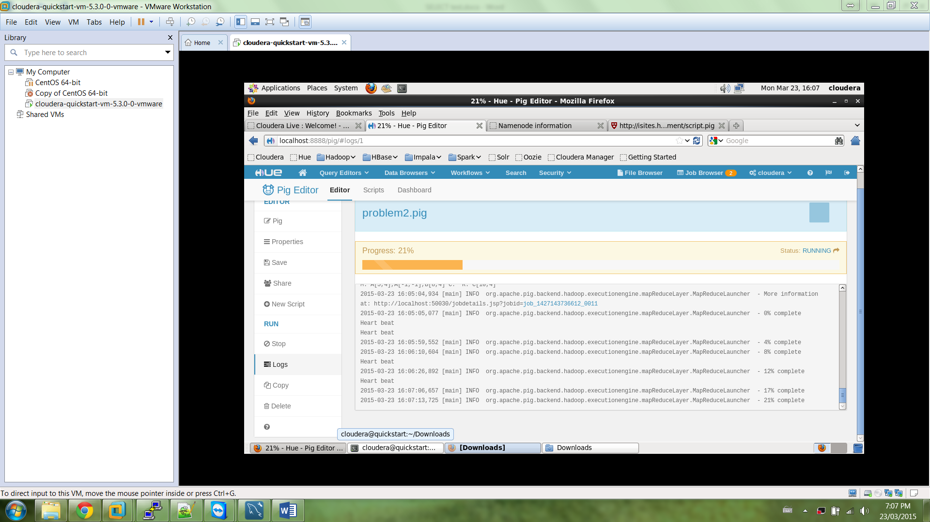

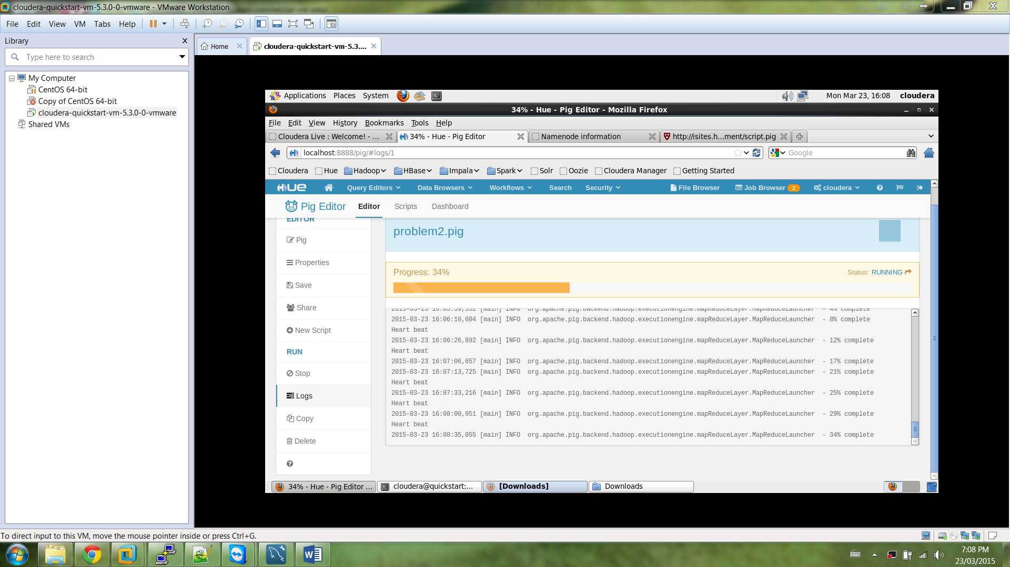

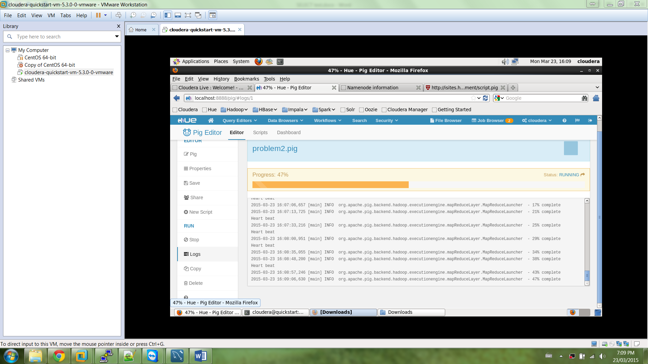

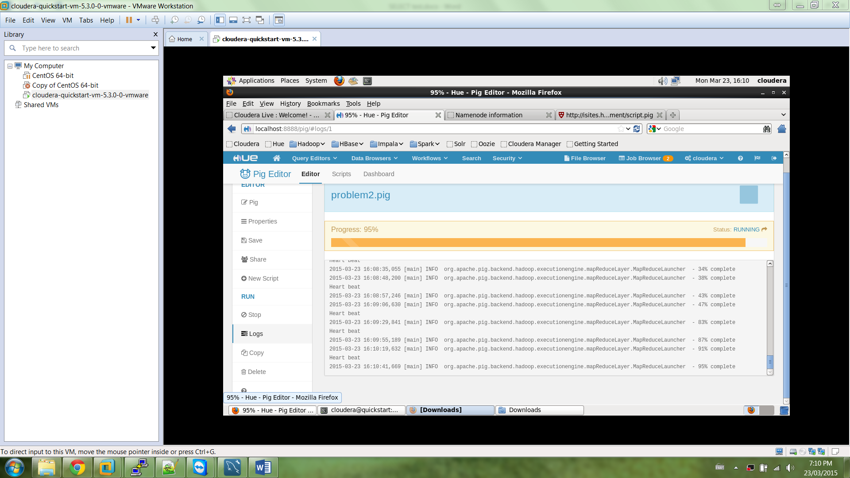

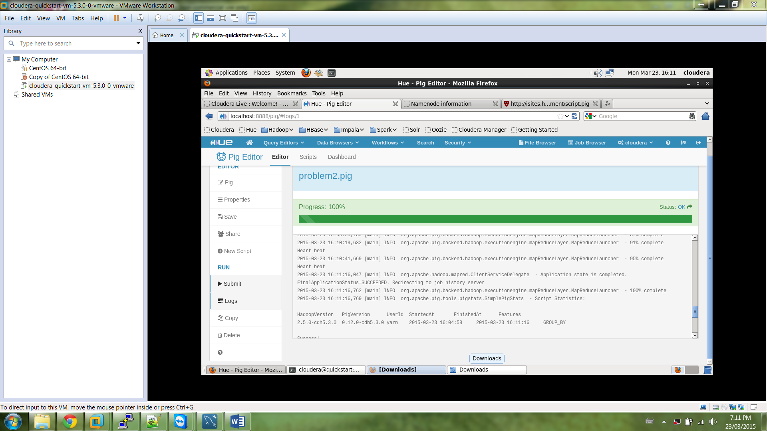

**Check output in output folder**

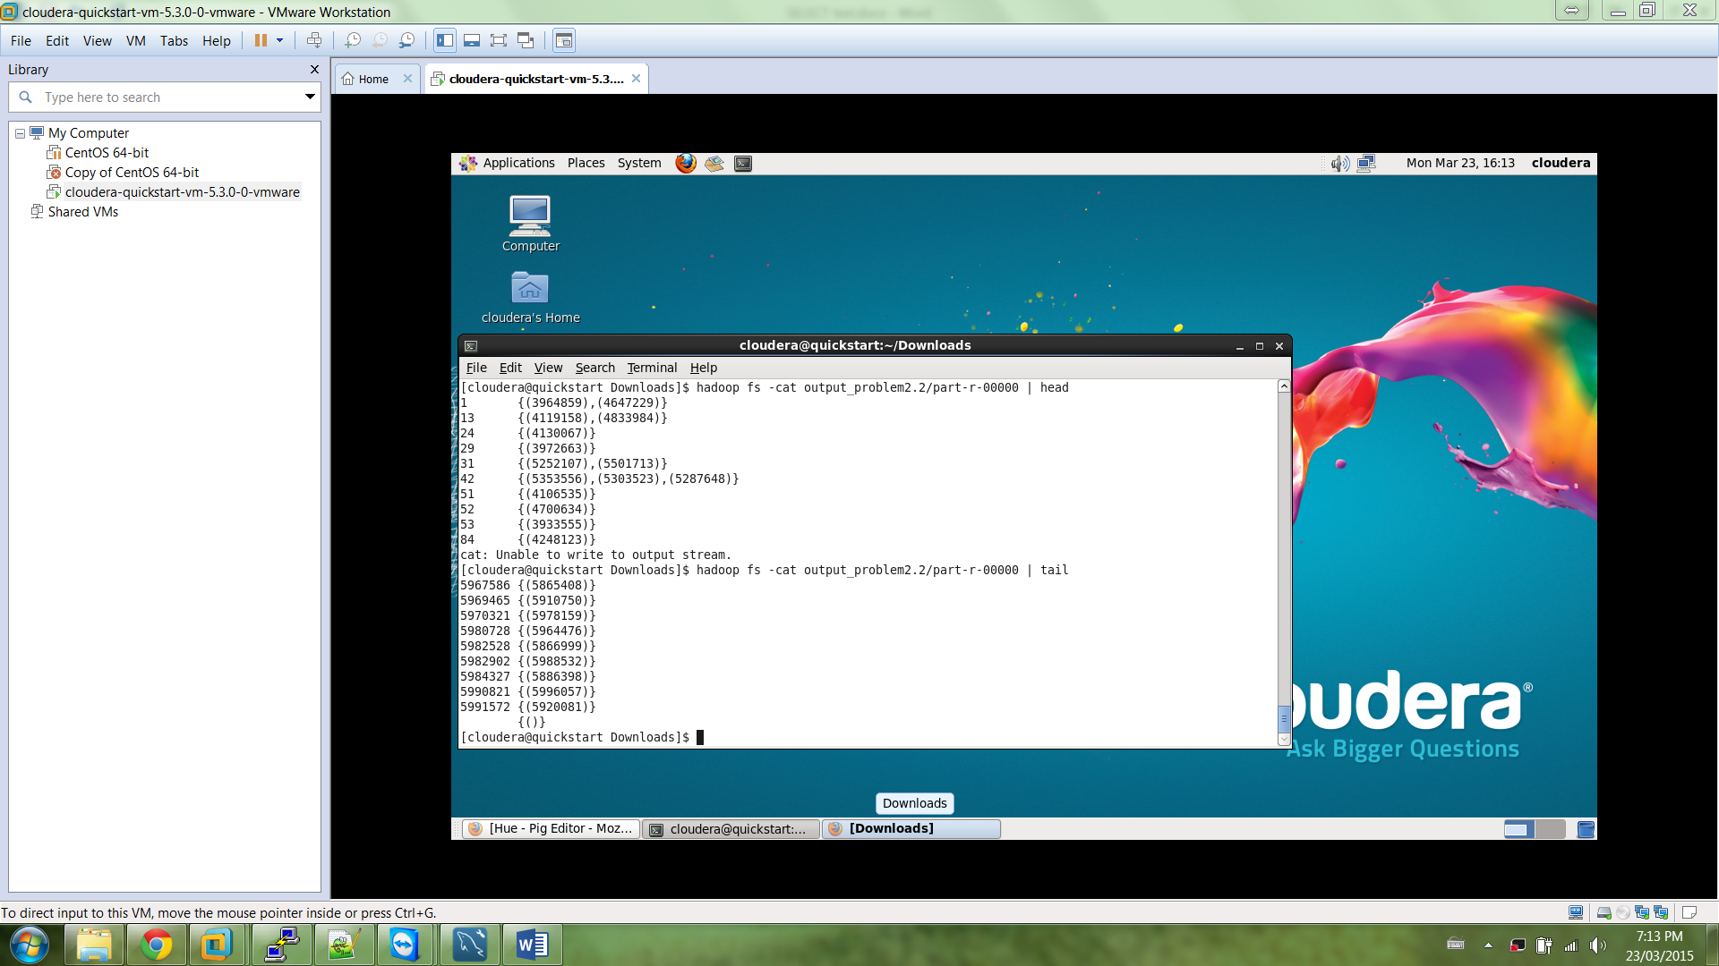

**Problem 3**

Produce the same output using MySQL

Create the table

CREATE TABLE `patent` (

`Citing` int(45) DEFAULT NULL,

`Cited` int(45) DEFAULT NULL

) ENGINE=InnoDB DEFAULT CHARSET=utf8;

Load the text file into table

LOAD DATA LOCAL INFILE 'C:\\Users\\Dilmi\\Documents\\Big Data Analytics\\cite75_99.txt' INTO

TABLE test.patent COLUMNS

TERMINATED BY ',' IGNORE 1 LINES;

Group the data by variable “cited” and concat the Citing values, sort in ASC order

SELECT test.patent.Cited, group_concat(test.patent.Citing)

FROM test.patent

GROUP BY test.patent.Cited ORDER BY Cited ASC;

Output from MySql Workbench

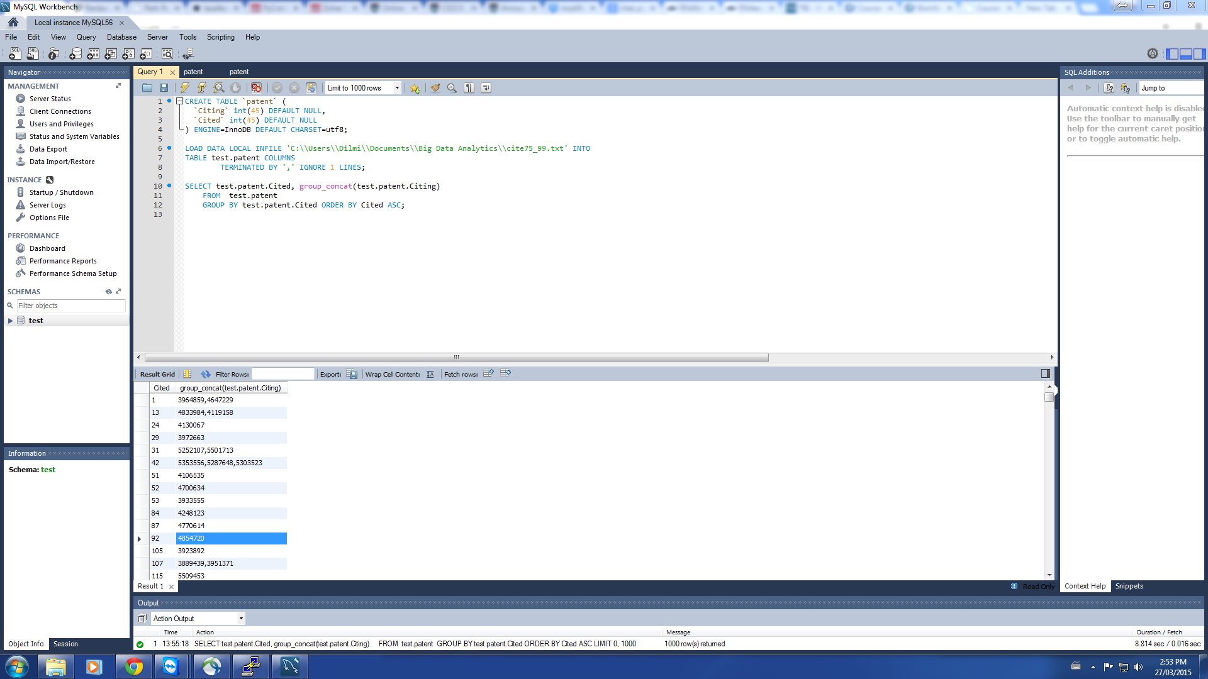

Store output in table “citedtocitingconcat”

CREATE TABLE `test`.`citedtocitingconcat` (

`Cited` int(11) NOT NULL,

`CitingConcat` VarChar(20000) DEFAULT NULL,

PRIMARY KEY (`Cited`)

);

Insert into test.CitedToCitingConcat

SELECT test.patent.Cited, group_concat(test.patent.Citing)

FROM test.patent

GROUP BY test.patent.Cited ORDER BY Cited ASC;

**Problem 4**

**Take input from output folder of Problem 2**

register /usr/lib/pig/piggybank.jar;

A = LOAD 'output_problem2.2/part-r-00000' USING PigStorage('\t') as (

cited:chararray, citingList:chararray);

B = FOREACH A GENERATE cited, COUNT(TOKENIZE(citingList,',')) as citationCount;

C = ORDER B BY citationCount DESC;

STORE C into 'output_problem4.6';

**Insert code in Pig Editor**

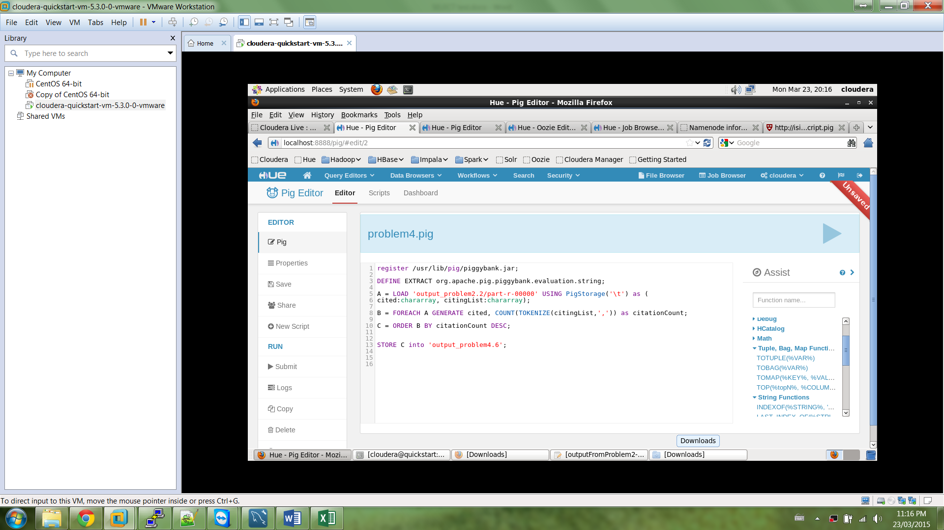

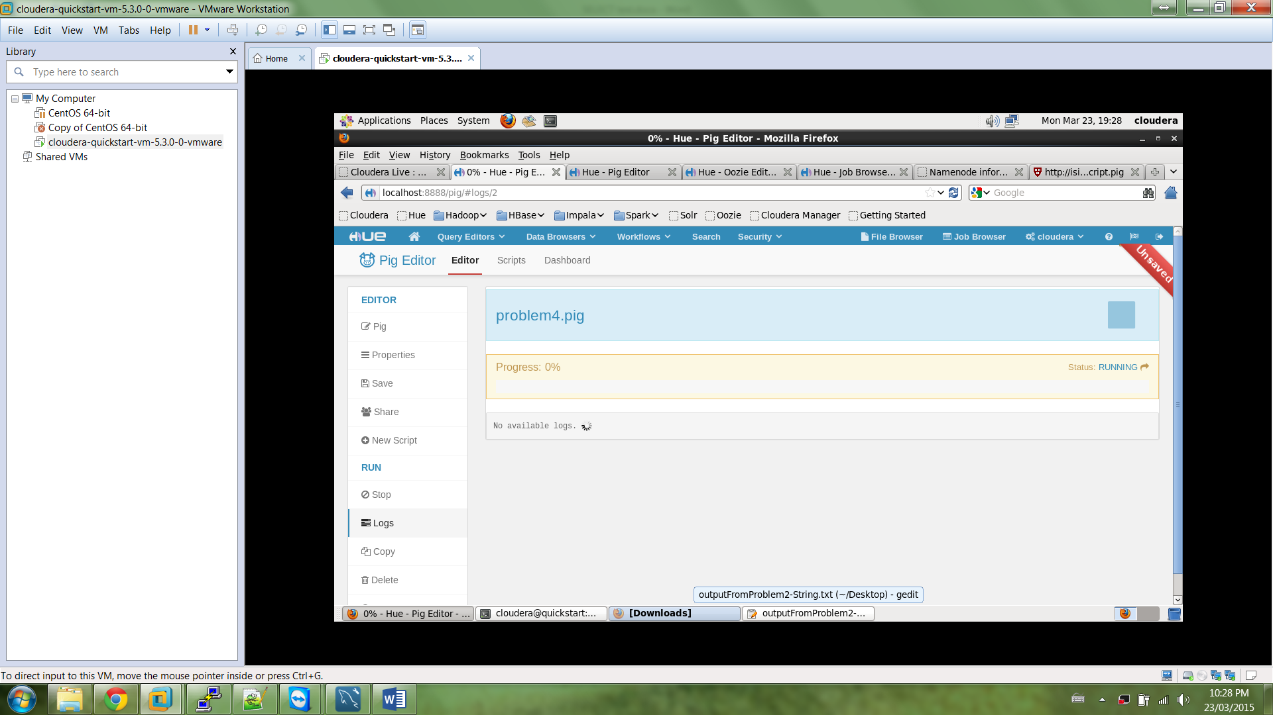

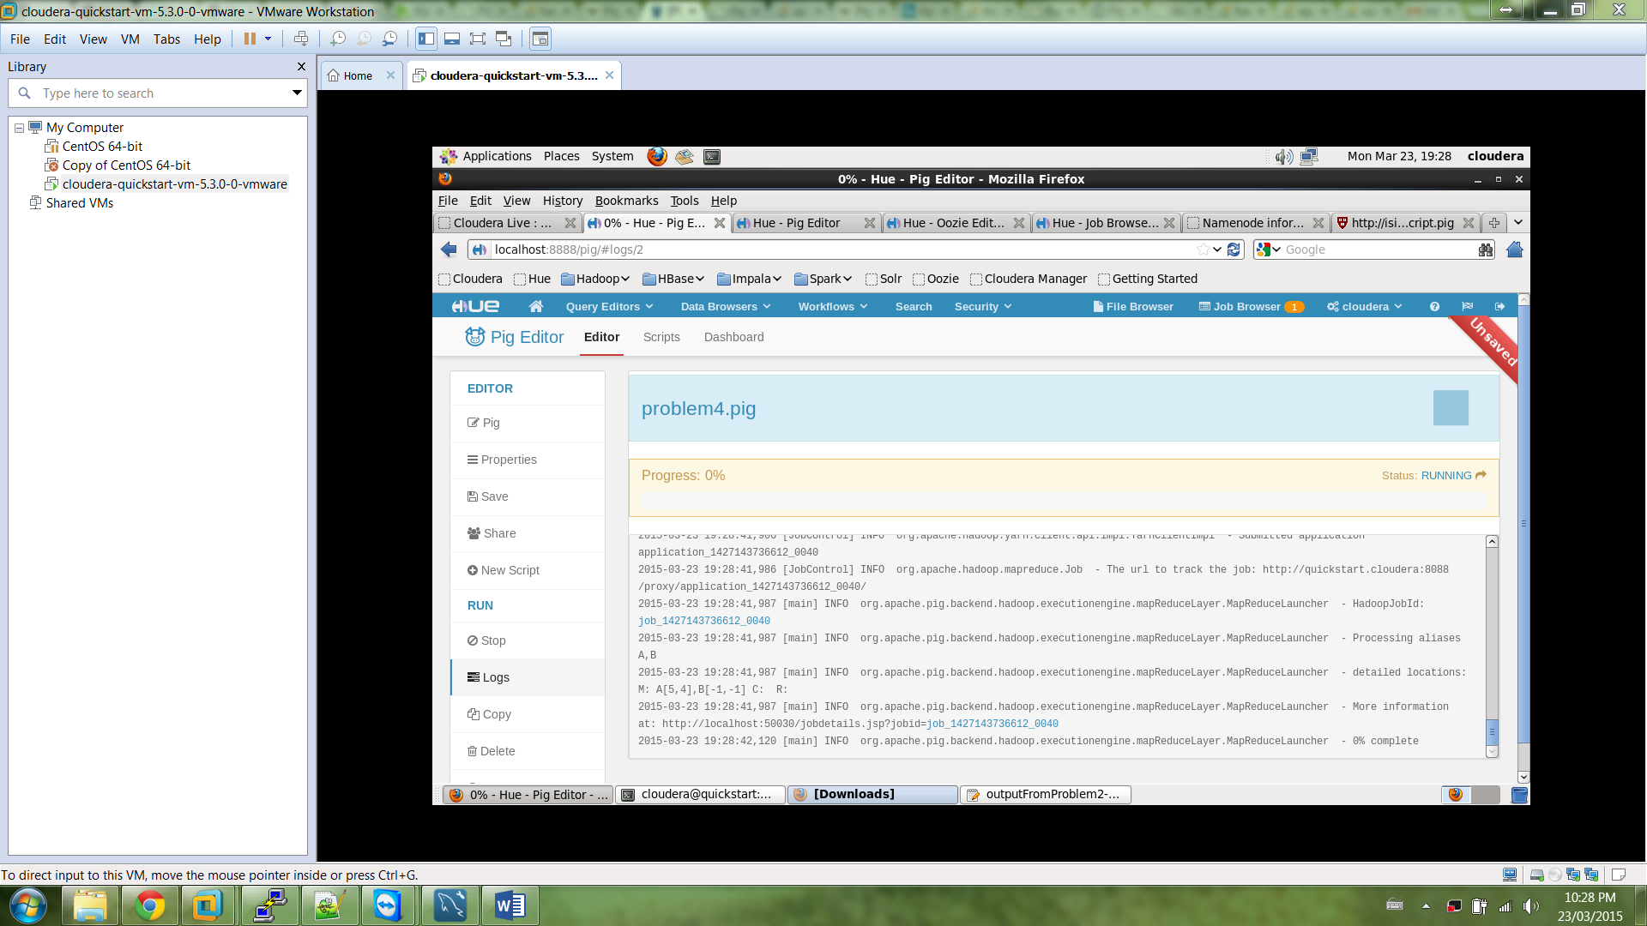

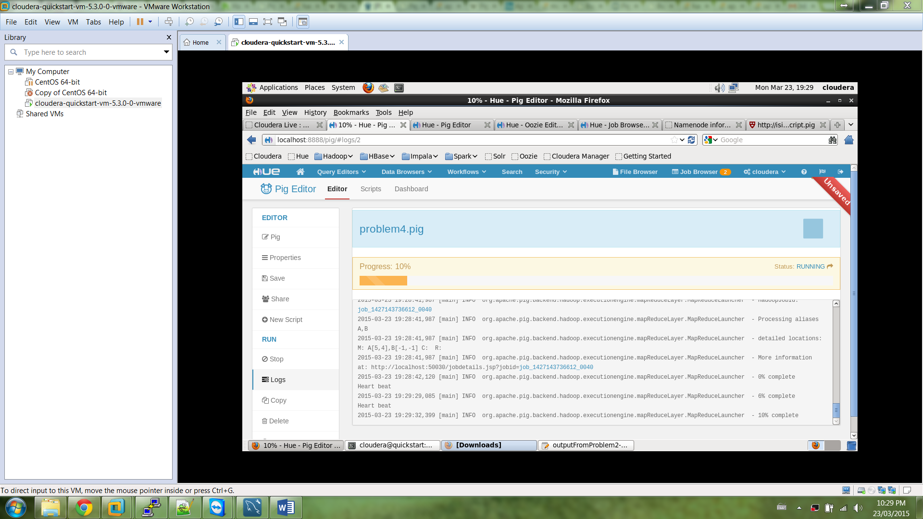

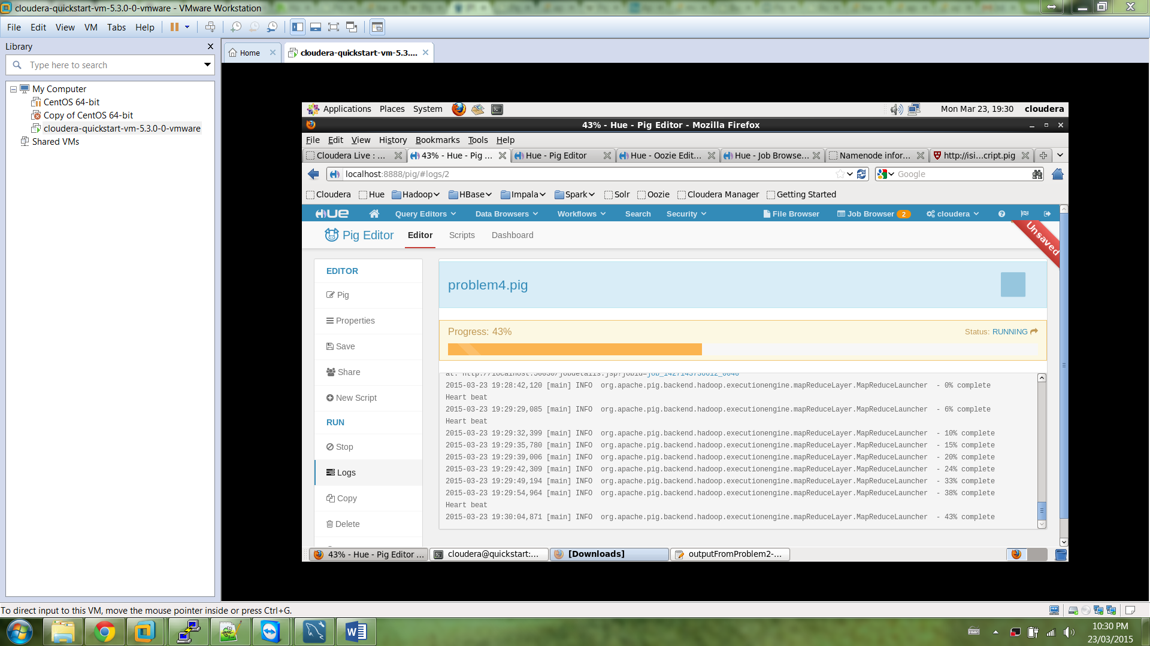

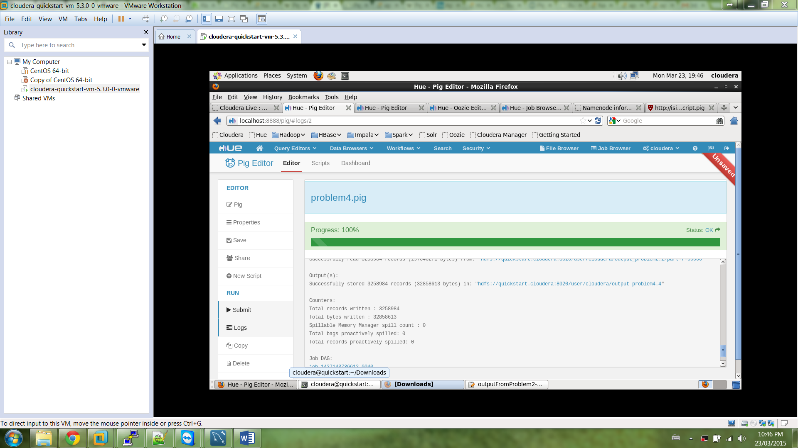

**Check output in output folder**

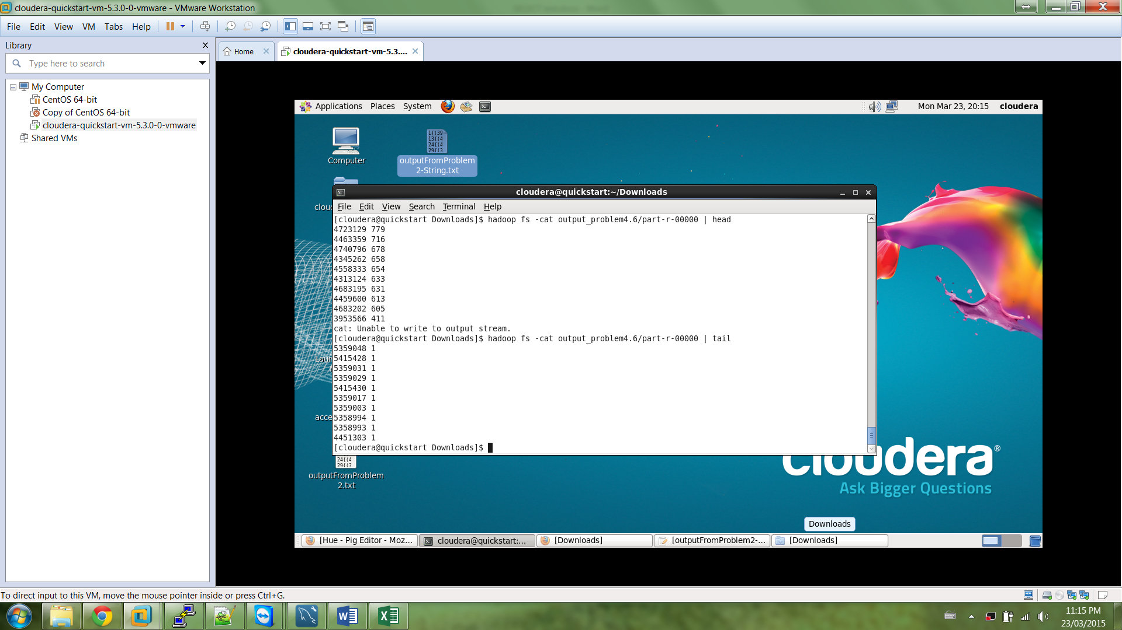

**Print first 20 rows sorted in descending order of citation number**

[cloudera@quickstart Downloads]$ hadoop fs -cat output_problem4.6/part-r-00000 | head -20

4723129 779

4463359 716

4740796 678

4345262 658

4558333 654

4313124 633

4683195 631

4459600 613

4683202 605

3953566 411

4367924 401

3702886 382

4733665 360

3845770 339

5103459 311

4535773 305

4358535 292

4655771 289

4901307 287

3849241 286

**Problem 5**

Part 1 - Sort output in descending order of number of citations

**register /usr/lib/pig/piggybank.jar;**

**A = LOAD 'output_problem4.6/part-r-00000' USING PigStorage('\t') as (**

**cited:chararray, citationCount:int);**

**B = GROUP A BY citationCount;**

**C = FOREACH B GENERATE $0 as countC, $1.cited as citations;**

**D = FOREACH C GENERATE countC, COUNT(citations) as citationFreq;**

**E = ORDER D BY countC DESC;**

**STORE E into 'output_problem5.11';**

**Insert code in Pig Editor and save script as “Problem5-DESC.pig”**

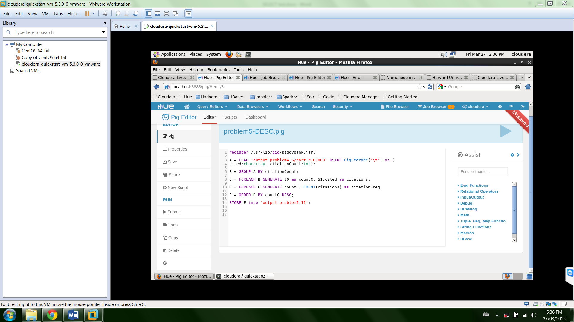

**Run script**

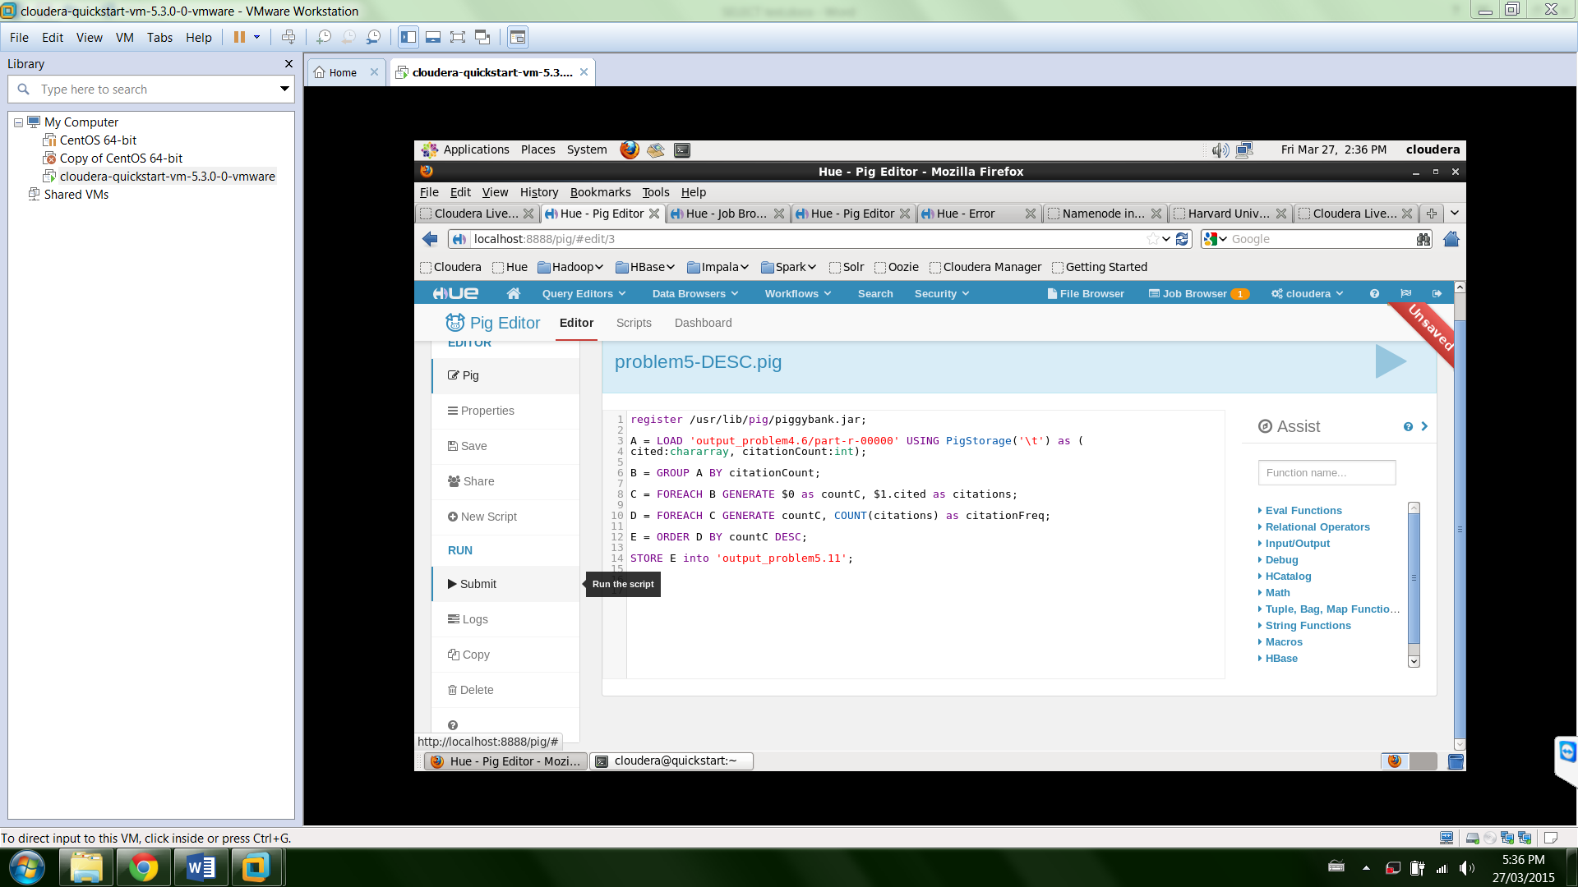

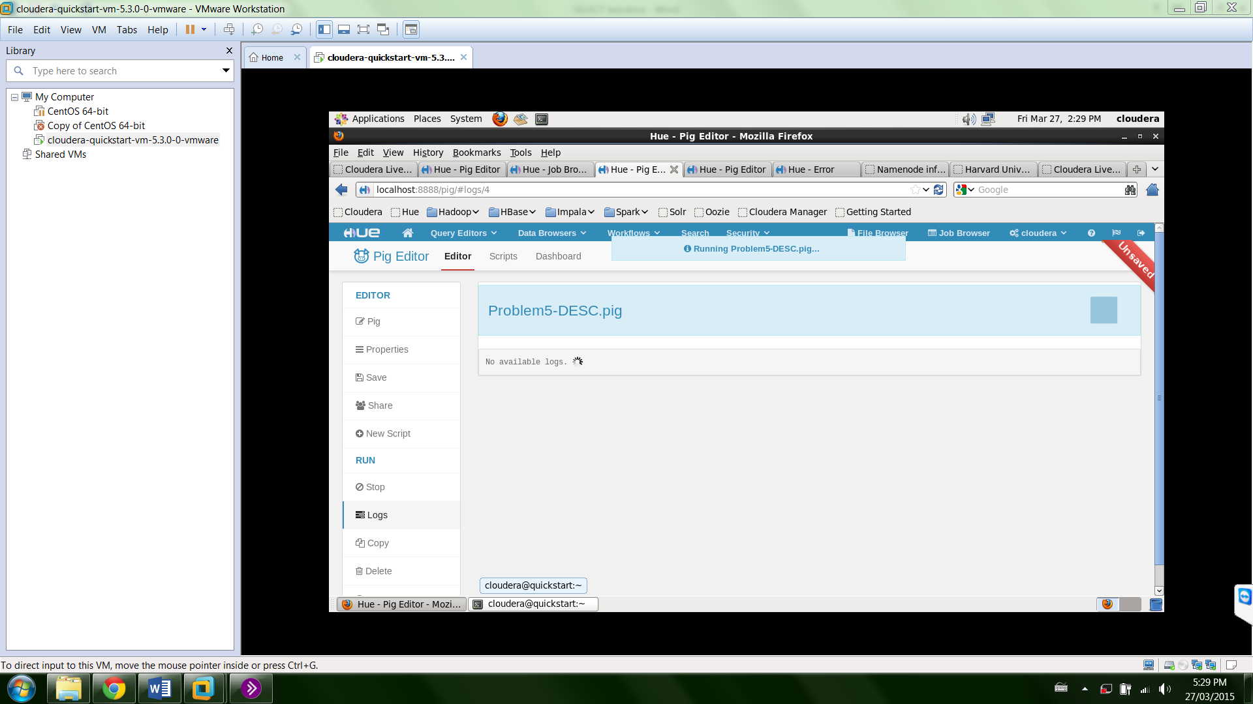

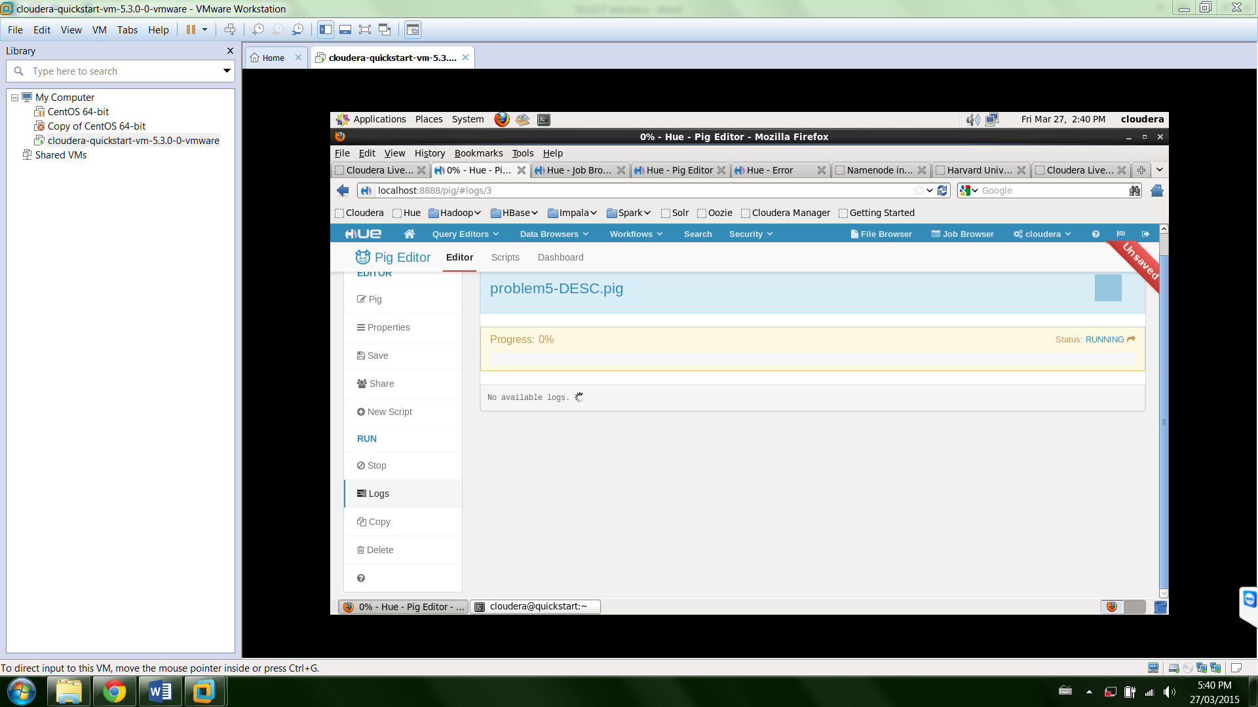

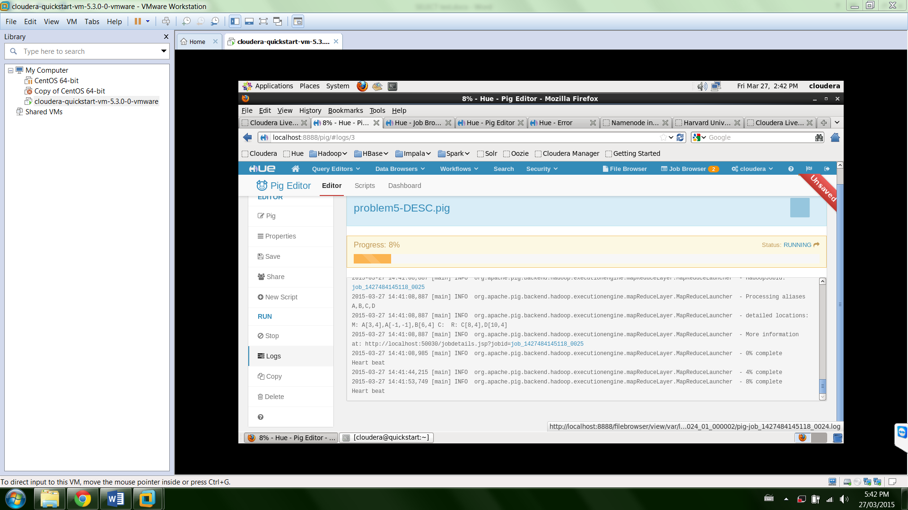

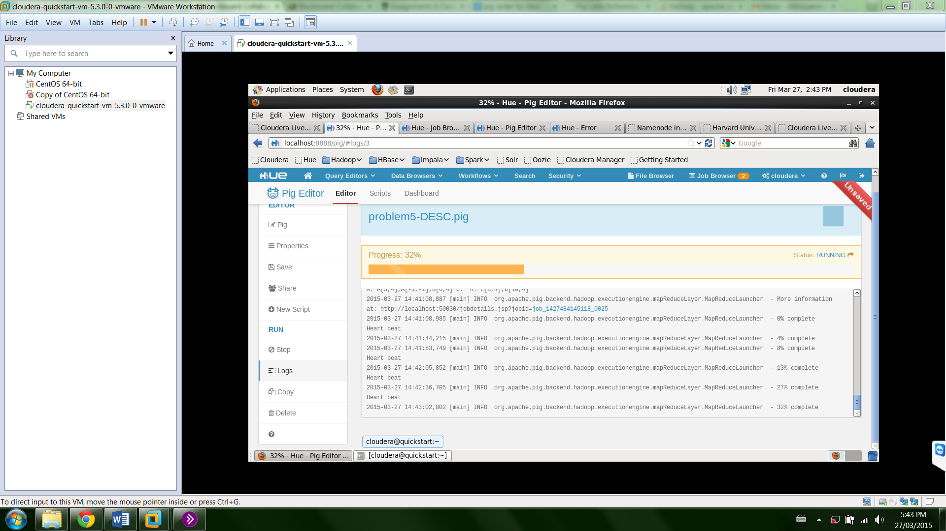

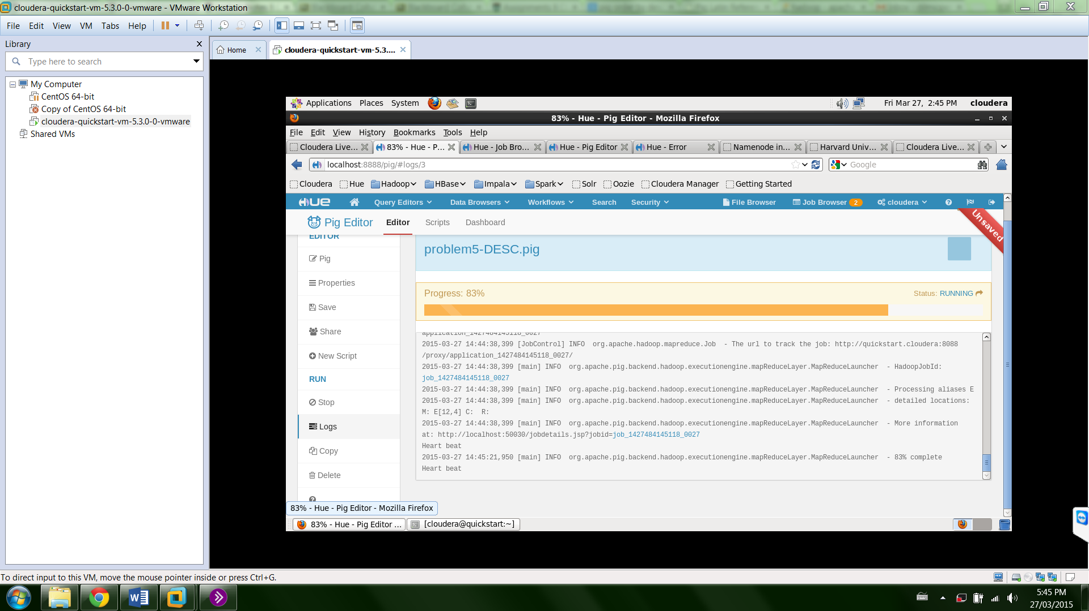

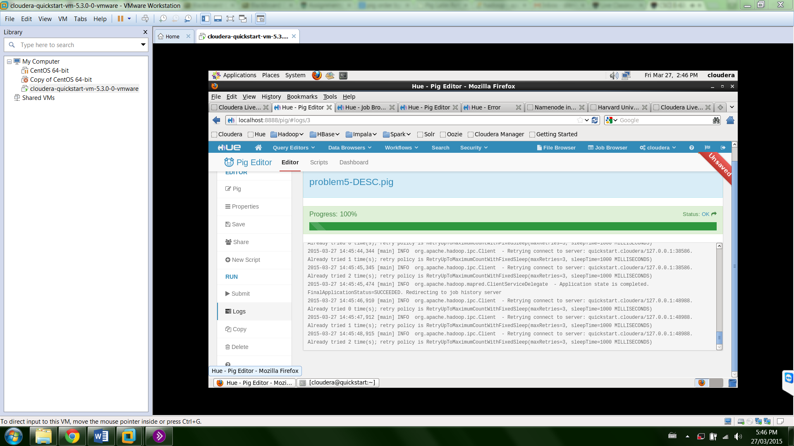

**Check output – print top 10 lines**

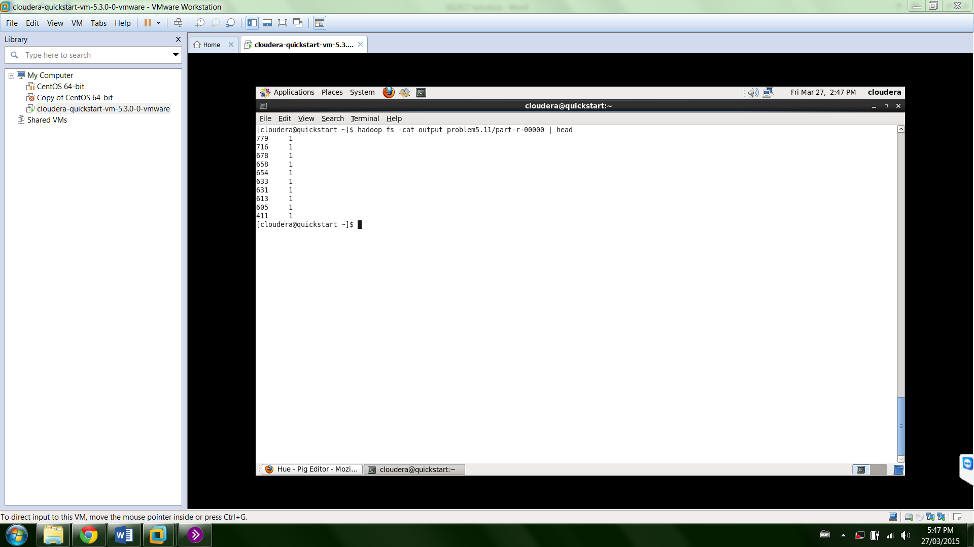

**[cloudera@quickstart ~]$ hadoop fs -cat output_problem5.11/part-r-00000 | head**

**779 1**

**716 1**

**678 1**

**658 1**

**654 1**

**633 1**

**631 1**

**613 1**

**605 1**

**411 1**

Part 2 - Sort output in descending order of number of citations

**register /usr/lib/pig/piggybank.jar;**

**A = LOAD 'output_problem4.6/part-r-00000' USING PigStorage('\t') as (**

**cited:chararray, citationCount:int);**

**B = GROUP A BY citationCount;**

**C = FOREACH B GENERATE $0 as countC, $1.cited as citations;**

**D = FOREACH C GENERATE countC, COUNT(citations) as citationFreq;**

**E = ORDER D BY countC ASC;**

**STORE E into 'output_problem5.12';**

**Insert code in Pig Editor and save script as “Problem5-ASC.pig”**

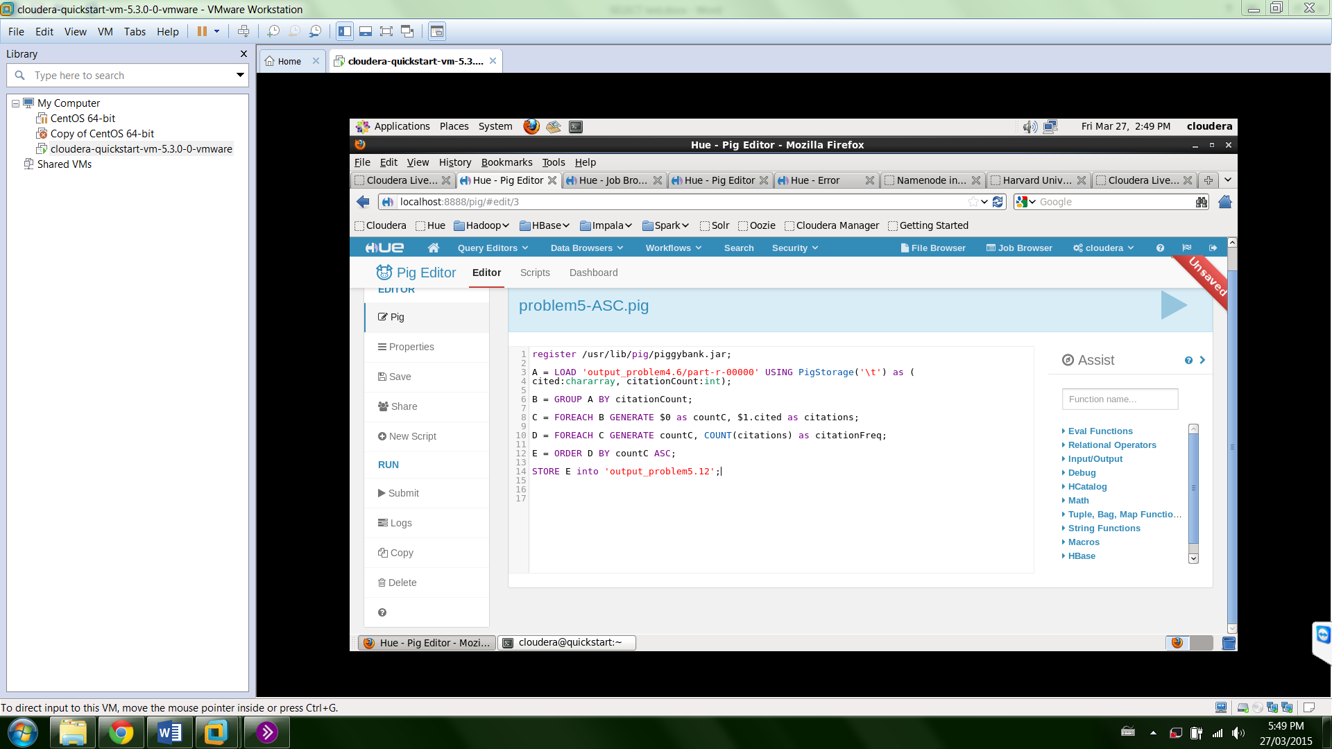

**Run script**

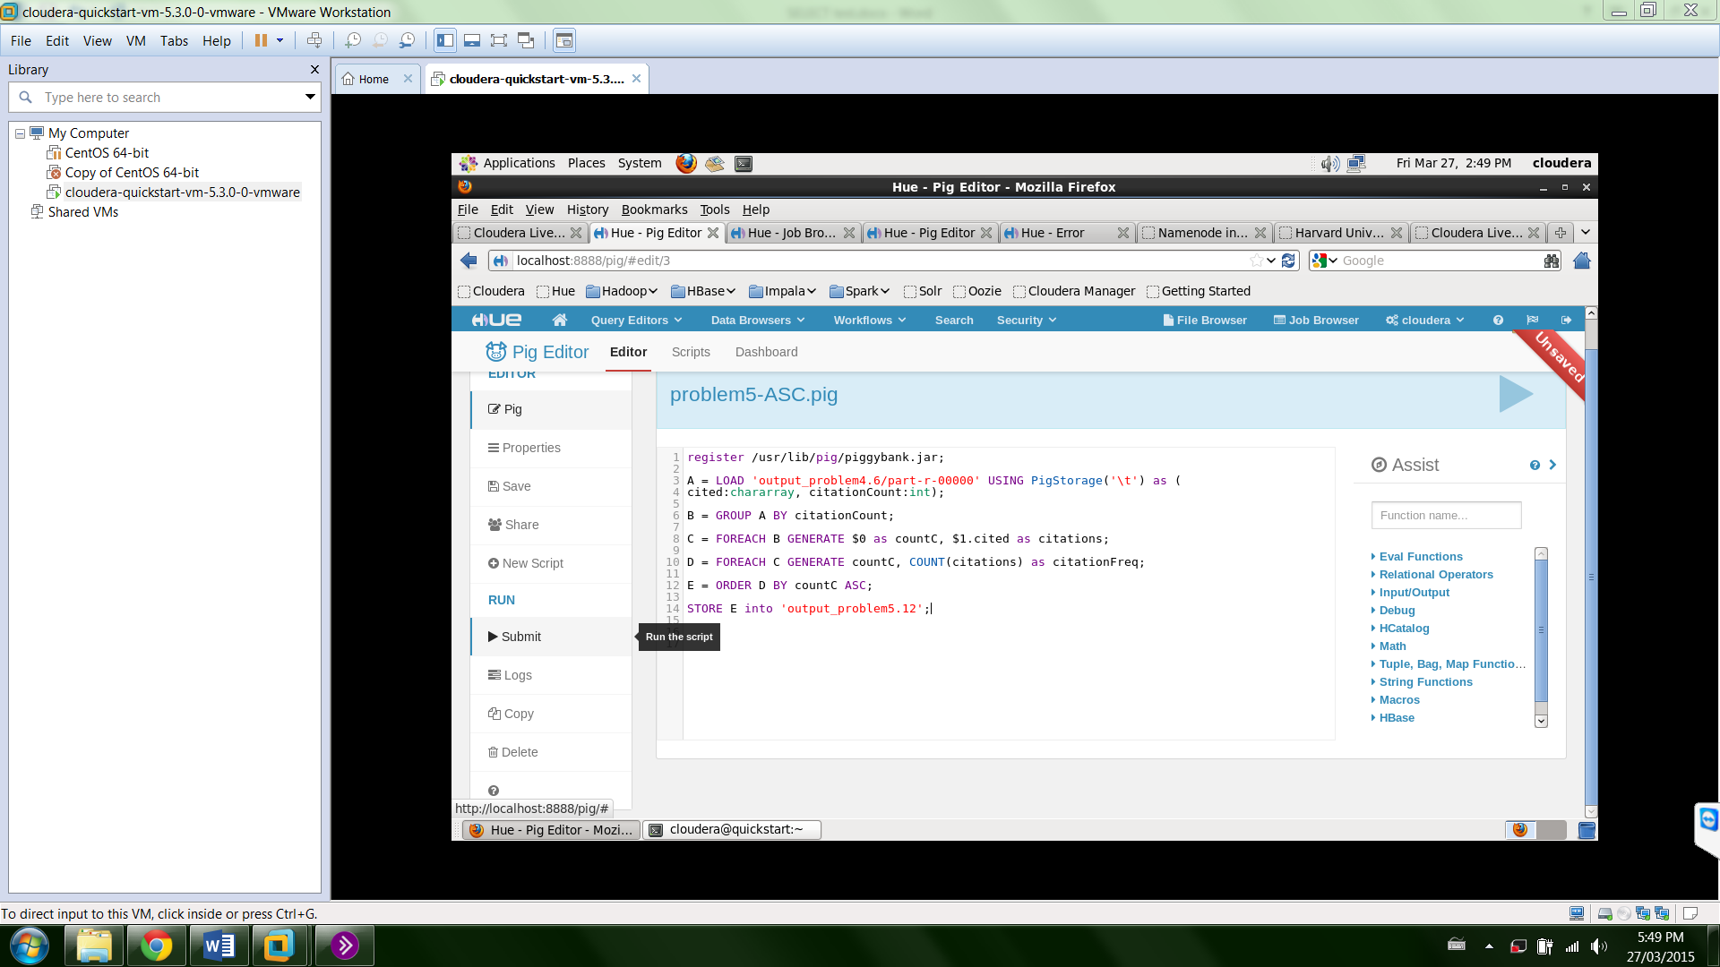

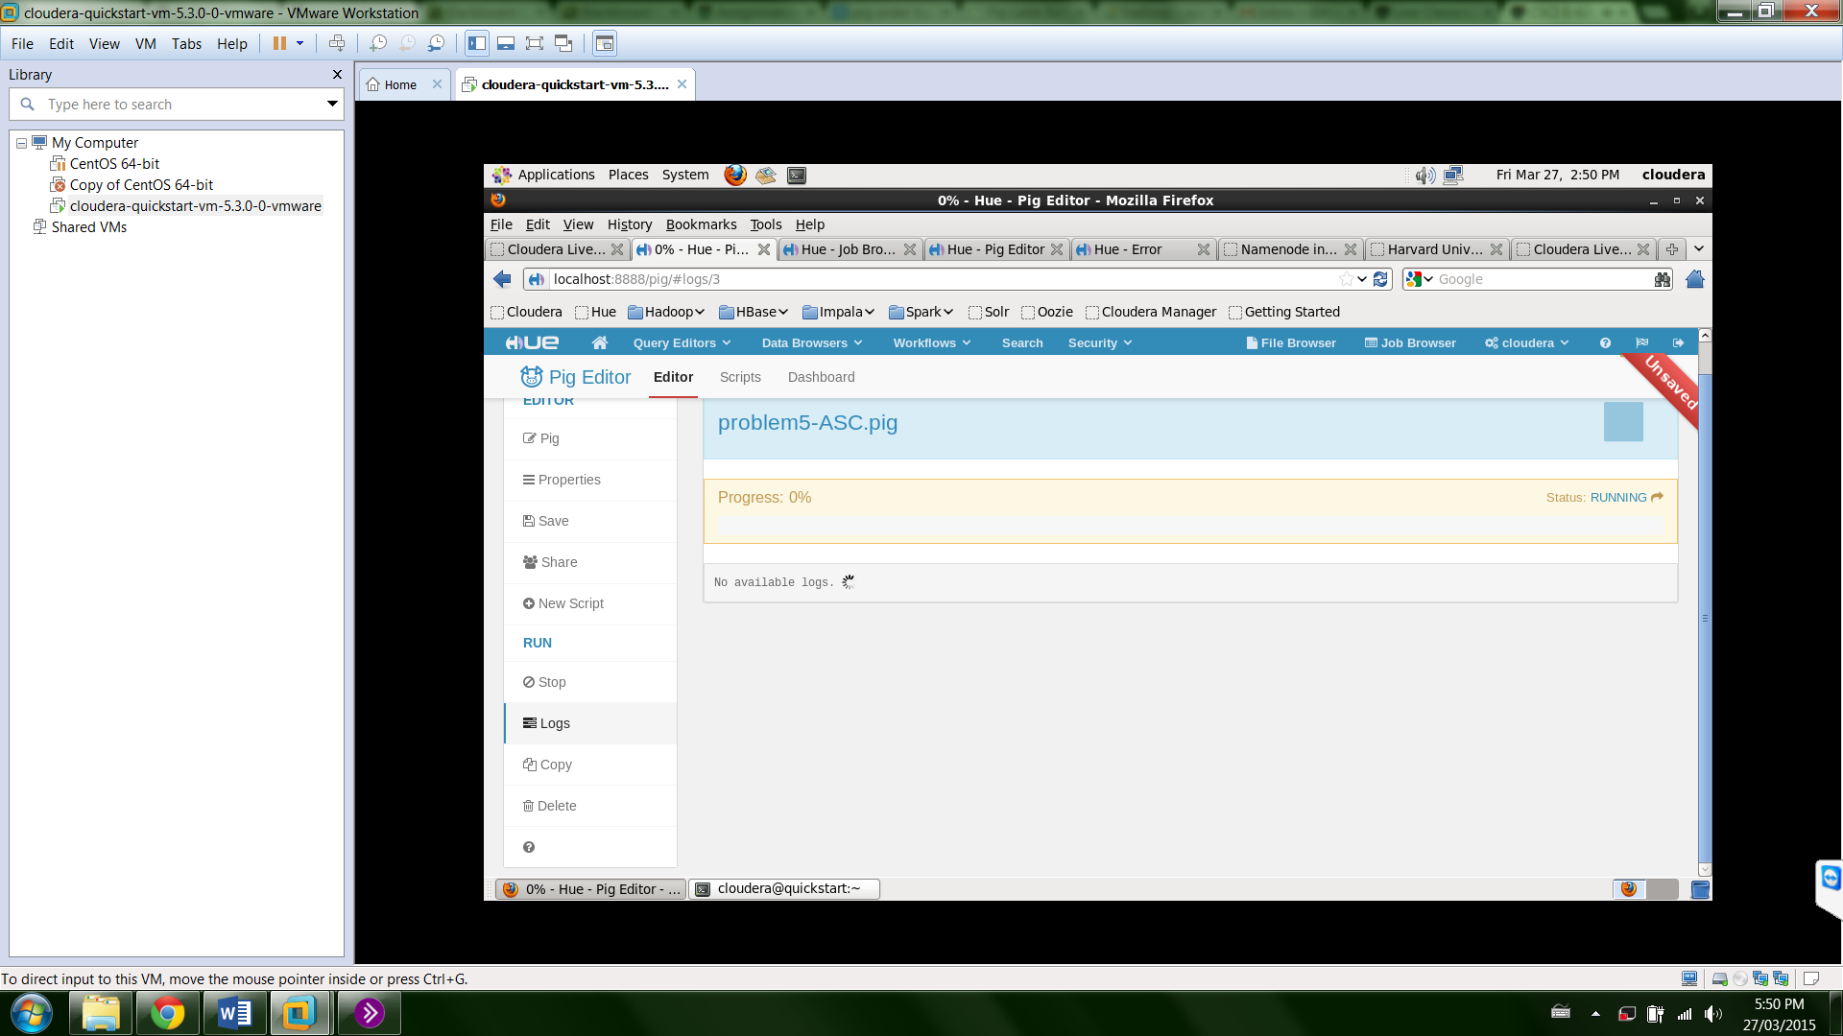

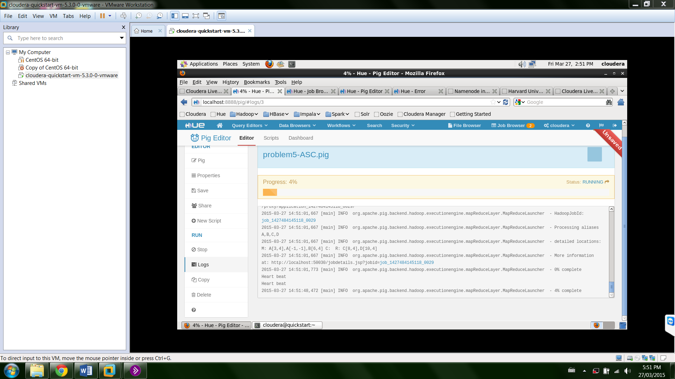

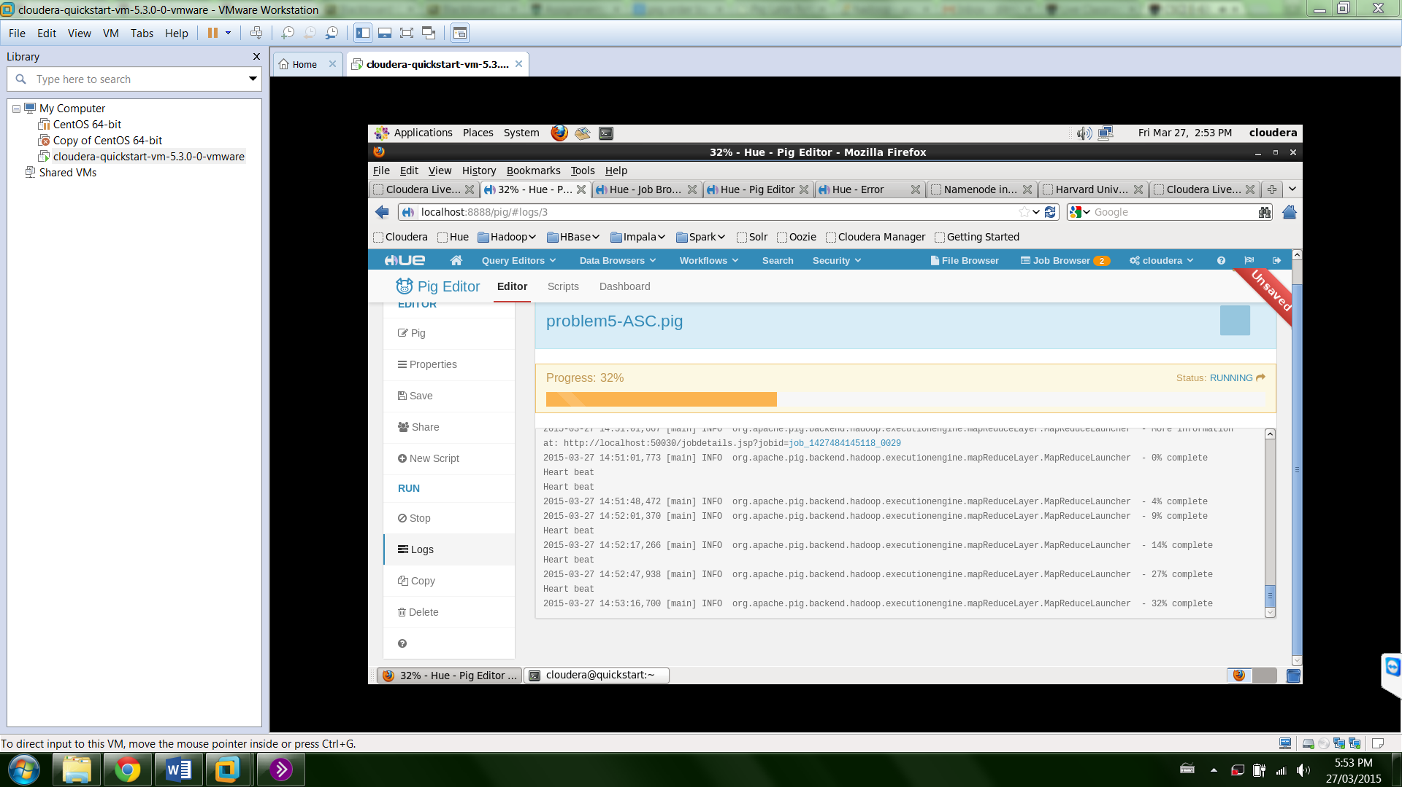

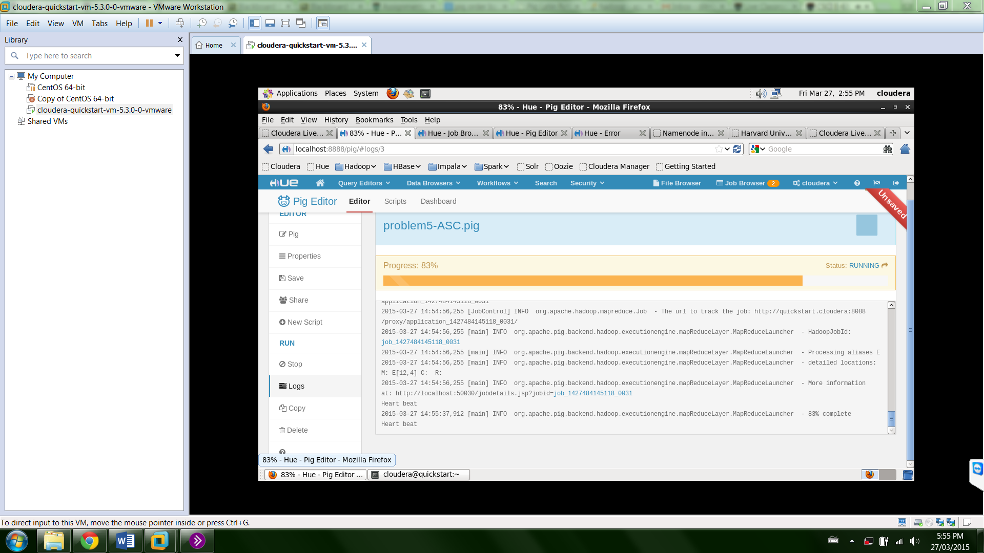

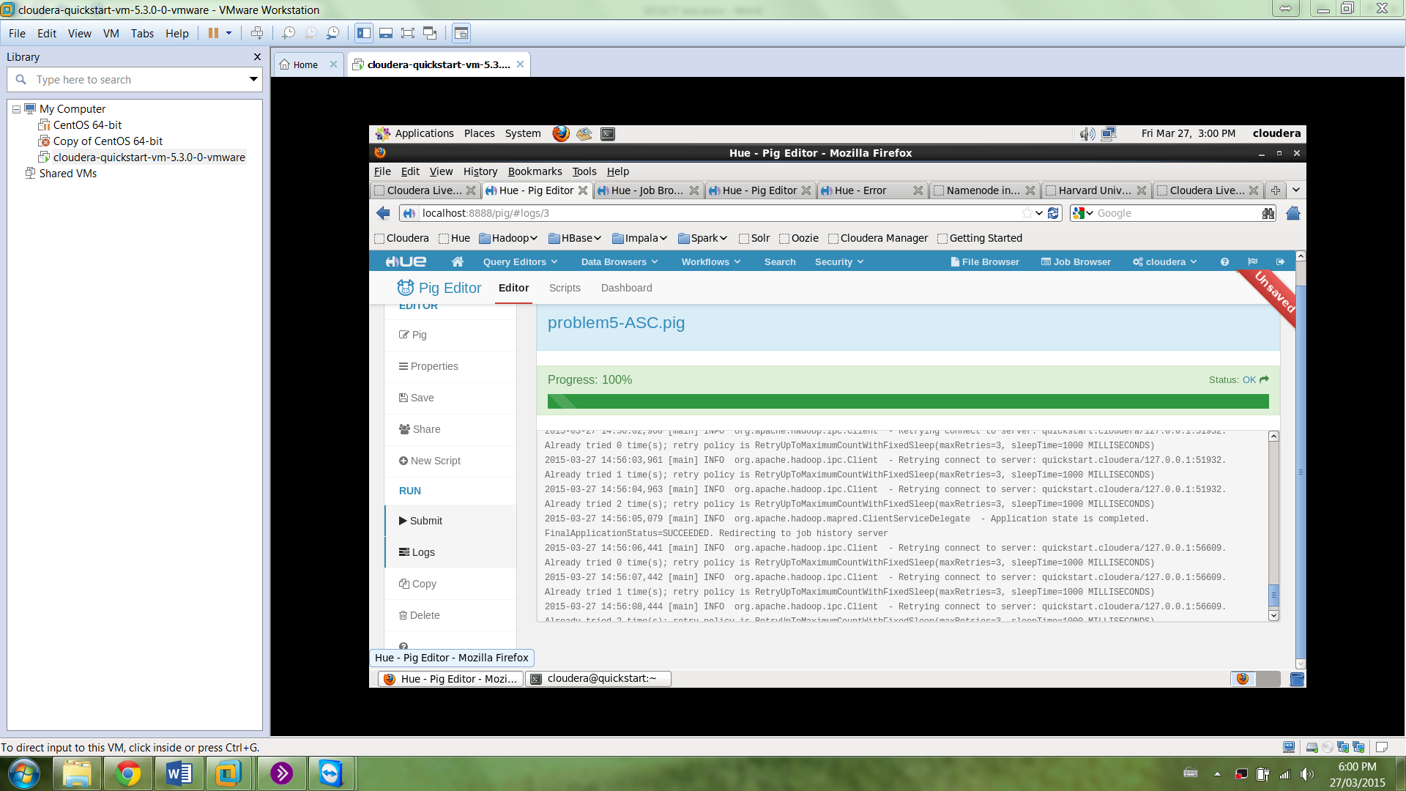

**Check output – print top 10 lines**

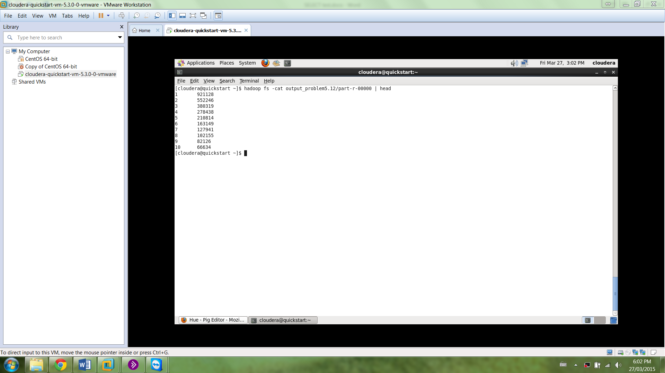

**[cloudera@quickstart ~]$ hadoop fs -cat output_problem5.12/part-r-00000 | head**

**1 921128**

**2 552246**

**3 380319**

**4 278438**

**5 210814**

**6 163149**

**7 127941**

**8 102155**

**9 82126**

**10 66634**

**Produce the same output in MySQL**

CREATE TABLE `test`.`citedtocitingcount` (

`Cited` int(11) NOT NULL,

`CitingCount` int(20) DEFAULT NULL,

PRIMARY KEY (`Cited`)

);

Insert into test.CitedToCitingCount

SELECT test.patent.Cited,count(test.patent.Citing)

FROM test.patent

GROUP BY test.patent.Cited;

SELECT CitingCount , COUNT(*) as count FROM test.CitedToCitingCount

GROUP BY CitingCount ORDER BY count DESC;

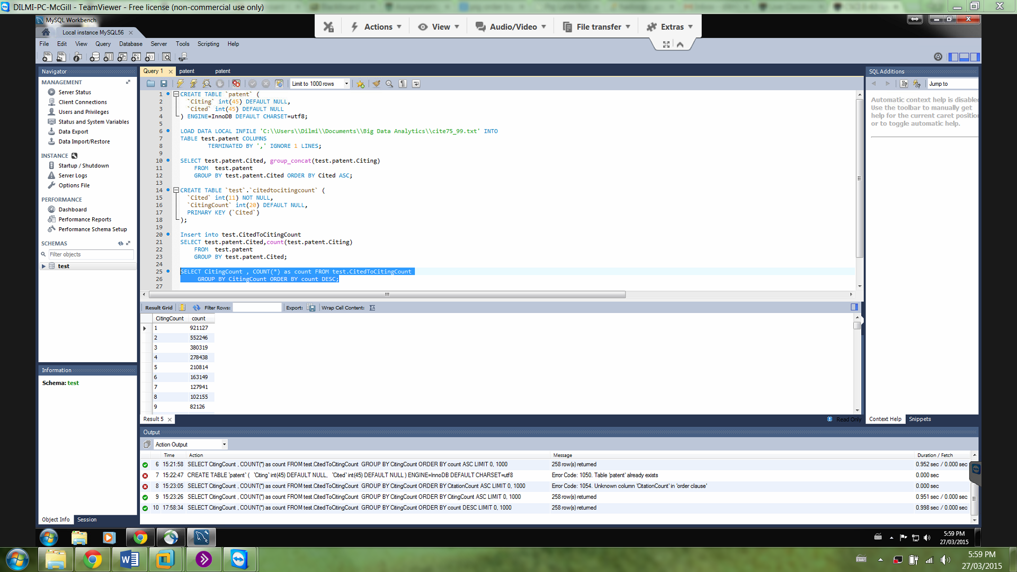

Output (First 10 lines):

'1', '921127'

'2', '552246'

'3', '380319'

'4', '278438'

'5', '210814'

'6', '163149'

'7', '127941'

'8', '102155'

'9', '82126'

'10', '66634'

SELECT CitingCount , COUNT(*) as count FROM test.CitedToCitingCount

GROUP BY CitingCount ORDER BY count ASC;

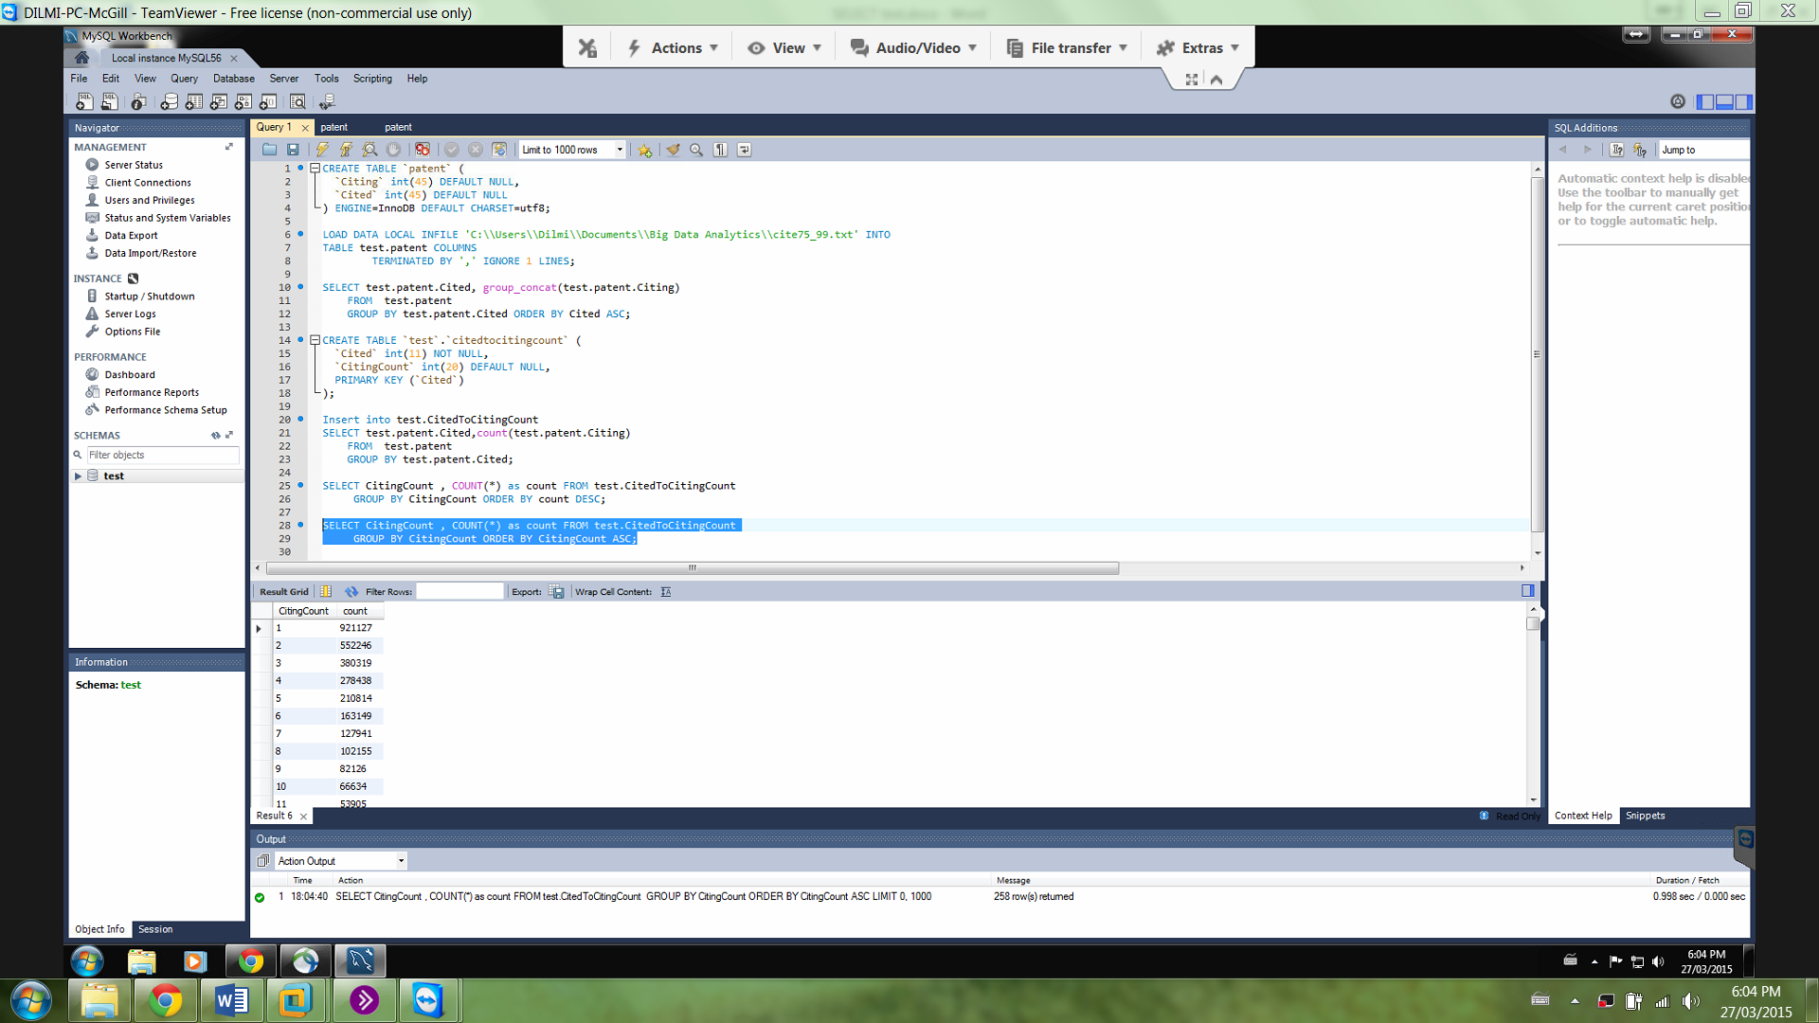

'1', '921127'

'2', '552246'

'3', '380319'

'4', '278438'

'5', '210814'

'6', '163149'

'7', '127941'

'8', '102155'

'9', '82126'

'10', '66634'